Multiple Object Tracking: A Literature Review
多目标跟踪：文献综述

Abstract—Multiple Object Tracking (MOT) is an important computer vision problem which has gained increasing attention due to its academic and commercial potential（学术和商业潜力）. Although different kinds of approaches have been proposed to tackle（处理） this problem, it still remains challenging due to factors（因素） like abrupt appearance changes（突然的外观变化） and severe object occlusions（严重的物体遮挡）. In this work, we contribute the first comprehensive（综合的） and most recent review（最新的评论） on this problem. We inspect（检查） the recent advances in various aspects and propose some interesting directions for future research. To the best of our knowledge（据我们所知）, there has not been any extensive（广泛的） review on this topic in the community. We endeavor（努力地） to provide a thorough review on the development of this problem in recent decades. The main contributions of this review are fourfold: 1) Key aspects in a multiple object tracking system, including formulation（构想）, categorization（分类）, key principles（关键原则）, evaluation（评价） of an MOT are discussed. 2) Instead of enumerating（枚举） individual works, we discuss existing approaches according to various aspects, in each of which methods are divided into different groups and each group is discussed in detail for the principles, advances and drawbacks. 3) We examine experiments of existing publications and summarize results on popular datasets to provide quantitative comparisons（定量比较）. We also point to some interesting discoveries by analyzing these results. 4) We provide a discussion about issues of MOT research, as well as some interesting directions which could possibly become potential research effort in the future

多目标跟踪（MOT）是一个重要的计算机视觉问题，由于其学术和商业潜力而受到越来越多的关注。虽然已经提出了不同类型的方法来解决这个问题，但由于突然的外观变化和严重的物体遮挡等因素，它仍然具有挑战性。在这项工作中，我们对这个问题做出了第一次全面和最新的评论。我们检查了各方面的最新进展，并为今后的研究提出了一些有趣的方向。据我们所知，社区中没有对此主题进行过任何广泛的审查。近几十年来，我们努力对这一问题的发展进行彻底的审查。本次审查的主要贡献有四个方面：1）讨论了多目标跟踪系统的关键方面，包括构建，分类，关键原则，对多目标跟踪的评估。 2）我们不是列举单个作品，而是根据各个方面讨论现有的方法，在每个方法中，方法被分成不同的组，并且每个组都要详细讨论原理，进展和缺点。 3）我们检查现有出版物的实验并总结流行数据集的结果，以提供定量比较。我们还通过分析这些结果指出了一些有趣的发现。 4）我们讨论了MOT研究的问题，以及一些可能成为未来潜在研究工作的有趣方向

1 I NTRODUCTION
Multiple Object Tracking (MOT), or Multiple Target Tracking (MTT), plays an important role in computer vision. The task of MOT is largely partitioned（划分为） to locating multiple objects, maintaining their identities, and yielding（生成） their individual trajectories（轨迹） given an input video. Objects to track can be, for example, pedestrians on the street ,vehicles in the road , sport players on the court or groups of animals (birds , bats , ants , fish ,cells etc.). Multiple “objects” could also be viewed as different parts of a single object. In this review, we mainly focus on the research on pedestrian tracking. The underlying（根本的） reasons for this specification（说明书） are threefold. First, compared to other common objects in our environment, pedestrians are typical nonrigid objects（非刚性物体）, which is an ideal example to study the MOT problem. Second, videos of pedestrians arise in a huge number of practical applications, which further results in great commercial potential. Third, according to all data collected for this review, at least 70% of current MOT research efforts are devoted to pedestrians.

多目标跟踪（MOT）或多目标跟踪（MTT）在计算机视觉中起着重要作用。 MOT的任务主要分为定位多个物体，保持其身份，并在给定输入视频的情况下产生各自的轨迹。要跟踪的对象可以是例如道街道上的行人，路上的车辆，球场上的运动员或动物群（鸟类，蝙蝠，蚂蚁，鱼，细胞等）。多个“对象”也可以被视为单个对象的不同部分[16]。在这篇综述中，我们主要关注行人跟踪研究。这个规范的根本原因有三个。首先，与我们环境中的其他常见物体相比，行人是典型的非刚性物体，这是研究MOT问题的理想示例。其次，行人的视频出现在大量的实际应用中，这进一步带来了巨大的商业潜力。第三，根据为本次审查收集的所有数据，目前MOT研究工作中至少有70％用于行人。（选择行人作为研究对象的原因）

跟踪街道上的行人： [1], [2]
[1] B. Yang, C. Huang, and R. Nevatia, “Learning affinities and dependencies for multi-target tracking using a CRF model,” in Proc. IEEE Comput. Soc. Conf. Comput. Vis. Pattern Recognit., 2011, pp. 1233–1240.
[2] S. Pellegrini, A. Ess, K. Schindler, and L. Van Gool, “You’ll never walk alone: Modeling social behavior for multi-target tracking,” in Proc. IEEE Int. Conf. Comput. Vis., 2009, pp. 261–268.

跟踪路上的车辆： [3], [4]
[3] D. Koller, J. Weber, and J. Malik, “Robust multiple car tracking with occlusion reasoning,” in Proc. Eur. Conf. Comput. Vis., 1994, pp. 189–196.
[4] M. Betke, E. Haritaoglu, and L. S. Davis, “Real-time multiple vehicle detection and tracking from a moving vehicle,” Mach. Vis. Appl., vol. 12, no. 2, pp. 69–83, Feb. 2000.

球场上的运动员：[5], [6], [7]
[5] W.-L. Lu, J.-A. Ting, J. Little, and K. Murphy, “Learning to track and identify players from broadcast sports videos,” IEEE Trans. Pattern Anal. Mach. Intel., vol. 35, no. 7, pp. 1704–1716, Jul. 2013.
[6] J. Xing, H. Ai, L. Liu, and S. Lao, “Multiple player tracking in sports video: a dual-mode two-way bayesian inference approach with progressive observation modeling,” IEEE Tran. Image Process., vol. 20, no. 6, pp. 1652–1667, Jun. 2011.
[7] P. Nillius, J. Sullivan, and S. Carlsson, “Multi-target tracking-linking identities using bayesian network inference,” in Proc. IEEE Comput. Soc. Conf. Comput. Vis. Pattern Recognit., 2006, pp.
2187–2194.

动物群：birds [8], bats [9], ants [10],fish [11], [12], [13], cells [14], [15], etc.

[8] W. Luo, T.-K. Kim, B. Stenger, X. Zhao, and R. Cipolla, “Bi-label propagation for generic multiple object tracking,” in Proc. IEEE Comput. Soc. Conf. Comput. Vis. Pattern Recognit., 2014, pp. 1290–1297.
[9] M. Betke, D. E. Hirsh, A. Bagchi, N. I. Hristov, N. C. Makris, and T. H. Kunz, “Tracking large variable numbers of objects in clutter,” in Proc. IEEE Comput. Soc. Conf. Comput. Vis. Pattern
Recognit., 2007, pp. 1–8.
[10] Z. Khan, T. Balch, and F. Dellaert, “An MCMC-based particle filter for tracking multiple interacting targets,” in Proc. Eur. Conf. Comput. Vis., 2004, pp. 279–290.
[11] C. Spampinato, Y.-H. Chen-Burger, G. Nadarajan, and R. B. Fisher, “Detecting, tracking and counting fish in low quality unconstrained underwater videos,” Proc. Int. Conf. Comput. Vis.
Theory Appl., pp. 514–519, 2008.
[12] C. Spampinato, S. Palazzo, D. Giordano, I. Kavasidis, F.-P. Lin, and Y.-T. Lin, “Covariance based fish tracking in real-life under- water environment,” in Proc. Int. Conf. Comput. Vis. Theory Appl.,
2012, pp. 409–414.
[13] E. Fontaine, A. H. Barr, and J. W. Burdick, “Model-based tracking of multiple worms and fish,” in Proc. IEEE Int. Conf. Comput. Vis. Workshops, 2007, pp. 1–13.
[14] E. Meijering, O. Dzyubachyk, I. Smal, and W. A. van Cappellen, “Tracking in cell and developmental biology,” Semin. Cell Dev. Biol., vol. 20, no. 8, pp. 894–902, Aug. 2009.
[15] K. Li, E. D. Miller, M. Chen, T. Kanade, L. E. Weiss, and P. G. Campbell, “Cell population tracking and lineage construction with spatiotemporal context,” Med. Image Anal., vol. 12, no. 5,
pp. 546–566, May 2008.

As a mid-level task in computer vision, multiple object tracking grounds high-level tasks such as pose estimation（姿态估计） [17], action recognition [18], and behavior analysis [19]. It has numerous practical applications, such as visual surveillance（视频监控） [20], human computer interaction（人机交互） [21] and virtual reality [22]. These practical requirements（实际需求） have sparked（鼓舞） enormous interest in this topic. Compared with Single Object Tracking (SOT), which primarily focuses on designing sophisticated（复杂的） appearance models and/or motion models to deal with challenging factors such as scale changes, out-of-plane rotations（平面外旋转） and illumination variations（光照变换）, multiple object tracking additionally requires two tasks to be solved:determining the number of objects, which typically varies over time, and maintaining their identities. Apart from the common challenges in both SOT and MOT, further key issues that complicate（使复杂） MOT include among others: 1) frequent occlusions, 2) initialization（初始化） and termination（终止） of tracks, 3) similar appearance, and 4) interactions among multiple objects. In order to deal with all these issues, a wide range of solutions have been proposed in the past decades.
These solutions concentrate（集中） on different aspects of an MOT system, making it difficult for MOT researchers, especially newcomers, to gain a comprehensive（全面地） understanding of this problem. Therefore, in this work we provide a review to discuss the various aspects of the multiple object tracking problem.

作为计算机视觉中的中级任务，多目标跟踪可以实现高级任务，如姿态估计，动作识别和行为分析。它有许多实际应用，如视觉监控，人机交互和虚拟现实。这些实际要求引起了人们对这一主题的极大兴趣。与单目标跟踪（SOT）相比，SOT主要专注于设计复杂的外观模型和/或 运动模型，以应对诸如尺度变化，平面外旋转和光照变化等挑战性因素，多目标跟踪还需要两个要解决的任务：确定通常随时间变化的对象数量，并保持其身份（也就是标签要正确）。除了在这两个SOT和MOT共同挑战，使MOT更复杂的另外的关键问题包括：1）经常阻塞，2）轨道的初始化和终止，3）相似的外观，以及4）多个物体之间的相互作用。为了解决所有这些问题，过去几十年提出了广泛的解决方案。
这些解决方案集中在MOT系统的不同方面，使得MOT研究人员，尤其是新手，难以全面了解这一问题。因此，在这项工作中，我们提供了一个审查，以讨论多目标跟踪问题的各个方面。

多目标跟踪可以实现的高级任务：

1.姿态估计 pose estimation
[17] T. Pfister, J. Charles, and A. Zisserman, “Flowing convnets for human pose estimation in videos,” in Proc. IEEE Int. Conf. Comput. Vis., 2015, pp. 1913–1921.

2.动作识别 action recognition
[18] W. Choi and S. Savarese, “A unified framework for multi-target tracking and collective activity recognition,” in Proc. Eur. Conf. Comput. Vis., 2012, pp. 215–230.

3.行为分析 behavior analysis
[19] W. Hu, T. Tan, L. Wang, and S. Maybank, “A survey on visual surveillance of object motion and behaviors,” IEEE Trans. Syst. Man Cybern. Part C-Appl. Rev., vol. 34, no. 3, pp. 334–352, Mar. 2004.

4.视频监控 visual surveillance
[20] X. Wang, “Intelligent multi-camera video surveillance: A review,”Pattern Recognit. Lett., vol. 34, no. 1, pp. 3–19, Jan. 2013.

5.人机交互 human computer interaction
[21] J. Candamo, M. Shreve, D. B. Goldgof, D. B. Sapper, and R. Kasturi, “Understanding transit scenes: A survey on human behavior-recognition algorithms,” IEEE Trans. Intell. Transp. Syst., vol. 11, no. 1, pp. 206–224, Jan. 2010.

6.虚拟现实 virtual reality
[22] H. Uchiyama and E. Marchand, “Object Detection and Pose Tracking for Augmented Reality: Recent Approaches,” in Proc. Korea-Japan Joint Workshop Frontiers Comput. Vis., 2012, pp. 721–730.

  - Differences from Other Related Reviews 与其他相关综述的差异

To the best of our knowledge, there has not been any comprehensive literature review on the topic of multiple object tracking. However, there have been some other reviews related to multiple object tracking, which are listed in Table 1. We group these surveys into three sets and highlight the differences from ours as follows.

据我们所知，还没有关于多目标跟踪全面性的文献综述。 但是，还有一些与多目标跟踪相关的综述，如表1所示。我们将这些调查分为三组，并突出显示与我们的差异如下。
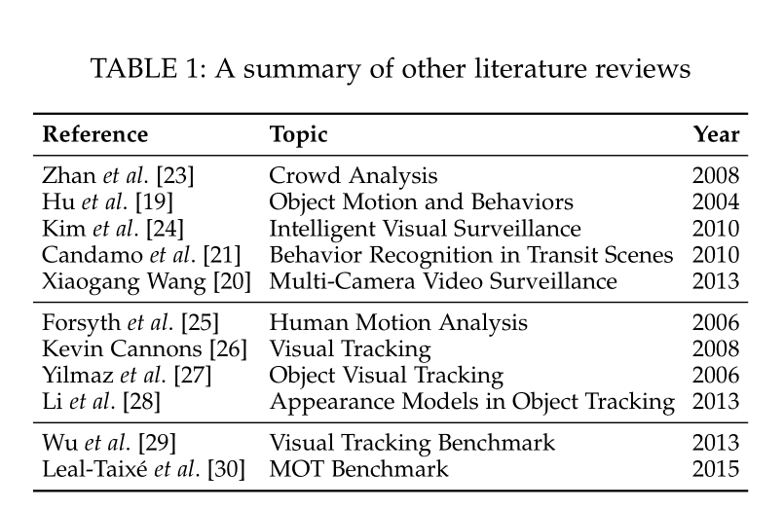
The first set [19], [20], [21], [23], [24] discusses tracking as an individual part while this work specifically discusses various aspects of MOT. For example, object tracking is discussed as a step in the procedure of high-level tasks such as crowd modeling [19], [23], [24]. Similarly, in [21] and [20], object tracking is reviewed as a part of a system for behavior recognition [21] or video surveillance [20].

第一组[19]，[20]，[21]，[23]，[24]讨论了跟踪作为一个单独的部分，而这项工作专门讨论了MOT的各个方面。 例如，目标跟踪作为高级任务过程中的一个步骤被讨论，如人群建模[19]，[23]，[24]。 同样，在[21]和[20]中，对象跟踪被视为行为识别系统[21]或视频监控系统[20]的一部分。

The second set [25], [26], [27], [28] is dedicated to general visual tracking techniques [25], [26], [27] or some special issues such as appearance models in visual tracking [28]. Their reviewing scope is wider than ours; ours on the contrary is more comprehensive and focused on multiple object tracking.

第二组[25]，[26]，[27]，[28]致力于一般视觉跟踪技术（如[25]，[26]，[27]）或一些特殊问题，如视觉跟踪中的外观模型[28]。 他们的审查范围比我们的范围更广; 相反，我们更全面，更专注于多目标跟踪。

The third set [29], [30] introduces and discusses benchmarks on general visual tracking [29] and on specific multiple object tracking [30]. Their attention is laid on experimental studies rather than literature reviews.
第三组[29]，[30]介绍并讨论了一般视觉跟踪[29]和特定多目标跟踪[30]的基准（基准是什么？）。 他们的注意力放在实验研究而不是文献综述上。

  - Contributions 贡献

We provide the first comprehensive review on the MOT problem to the computer vision community, which we believe is helpful to understand this problem, its main challenges, pitfalls, and the state of the art. The main contributions of this review are summarized as follows:

我们向计算机视觉社区提供有关MOT问题的第一次全面审查，我们认为这有助于理解这个问题，它的主要挑战，陷阱和最新技术水平。 本次审查的主要贡献概述如下：

We derive（起源，获得） a unified（统一的） formulation of the MOT problem which consolidates（巩固，整合） most of the existing MOT methods (Section 2.1), and two different ways to categorize MOT methods (Section 2.2).

我们得出了MOT问题的统一表述，它整合了大多数现有的MOT方法（第2.1节），以及两种不同的方法来分类MOT方法（第2.2节）。

We investigate different key components（成分，组件） involved in an MOT system, each of which is further divided into different aspects and discussed in detail regarding its principles, advances, and drawbacks (Section 3).

我们研究了MOT系统中涉及的不同关键部分，每个部分都进一步划分为不同的方面，并详细讨论了其原理，进展和缺点（第3节）。

Experimental results on popular datasets regarding different approaches are presented, which makes future experimental comparison convenient. By investigating the provided results, some interesting observations and findings are revealed (Section 4).

给出了将不同方法的用于流行数据集的实验结果，使得未来的实验对比更方便。 通过调查提供的结果，揭示了一些有趣的观察和发现（第4节）。

By summarizing the MOT review, we unveil existing issues of MOT research. Furthermore, open problems are discussed to identify potential future research directions (Section 5).

通过总结MOT综述，我们揭示了MOT研究的现有问题。 此外，还讨论了开放性问题，以确定未来可能的研究方向（第5节）。

Note that this work is mainly dedicated to reviewing recent literature on the advances in multiple object tracking. As mentioned above, we also present experimental results on publicly available datasets excepted from existing publications to provide a quantitative（定量的） view on the state-of-the-art（最先进的） MOT methods. For standardized benchmarking of multiple object tracking we kindly refer the readers to the recent work MOTChallenge by Leal-Taixé et al. [30].

请注意，这项工作主要致力于回顾有关多目标跟踪进展的最新文献。 如上所述，我们还提供了除现有出版物之外的公开数据集的实验结果，以提供关于最先进的MOT方法的定量观点。 对于多目标跟踪的标准化基准测试，我们请读者参考Leal-Taixé等人最近的MOTChallenge工作。[30]。
  - Organization of This Review 本综述的组织结构

Our goal is to provide an overview of the major aspects in the MOT task. These aspects include the current state of research in MOT, all the detailed issues requiring consideration in building a system, and how to evaluate an MOT system. Section 2 describes the MOT problem, including its general formulation (Section 2.1) and typical ways for categorization (Section 2.2). Section 3 contributes to the most common components involved in modeling multi-object tracking, i.e., appearance model (Section 3.1), motion model (Section 3.2), interaction model (Section 3.3), exclusion model (Section 3.4), occlusion handling (Section 3.5), and inference methods (Section 3.6). Furthermore, issues concerning evaluations, including metrics (Section 4.1), public datasets (Section 4.2), public codes (Section 4.3), and benchmark results (Section 4.4) are discussed in Section 4. This part is followed by Section 5 which summarizes the existing issues and interesting problems for future directions of the MOT research in the community.

我们的目标是一个提供MOT任务主要方面的综述。这些方面包括MOT的当前研究状况，构建系统时需要考虑的所有详细问题，以及如何评估MOT系统。第2节描述了MOT问题，包括其一般表述（第2.1节）和典型的分类方法（第2.2节）。第3节有助于构建多目标跟踪所涉及的最常见组件，即外观模型（第3.1节），运动模型（第3.2节），交互模型（第3.3节），排除模型（第3.4节），遮挡处理（部分） 3.5）和推理方法（第3.6节）。此外，第4节讨论了有关评估的问题，包括指标（第4.1节），公共数据集（第4.2节），公共代码（第4.3节）和基准结果（第4.4节）。本部分后面是第5节，其中总结了关于社区中MOT研究未来发展方向的现有问题和有趣问题。

1.4 Denotations 符号表示
Throughout this manuscript, we denote scalar（标量） and vector variables（变量） by lowercase letters (e.g., x ) and bold lowercase letters (e.g., x ), respectively. We use bold capital letters (e.g., X ) to denote a matrix or a set of vectors. Capital letters (e.g., X ) are adopted for specific functions or variables.Table 2 lists symbols utilized throughout this review. Except the symbols in the table, there may be some symbols for a specific reference. As these symbols are not commonly employed, they are not listed in the table but will be rather defined in the context.

在整个手稿中，我们分别用小写字母（例如x）和粗体小写字母（例如x）表示标量和向量变量。 我们使用粗体大写字母（例如，X）来表示矩阵或一组向量。 对于特定函数或变量采用大写字母（例如，X）。表2列出了本综述中使用的符号。 除表中的符号外，可能还有一些符号用于特定参考。 由于这些符号并不常用，因此它们未在表中列出，而是在上下文中定义。

x 标量 x 向量 X 矩阵 X 特定的函数或变量

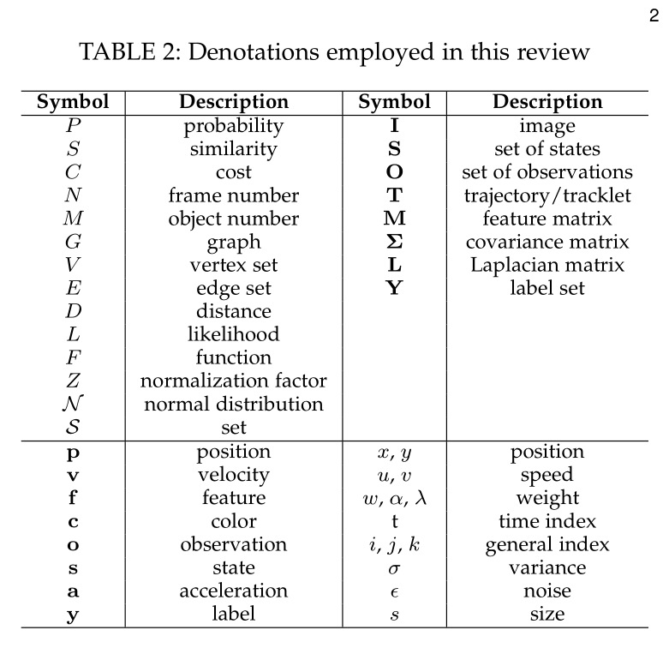

V vertex set 顶点集 L likelihood 可能性
v velocity 速度

2 MOT PROBLEM 多目标跟踪问题

We first endeavor to give a general mathematical formulation of MOT. We then discuss its possible categorizations based on different aspects.

我们首先努力给出MOT的一般数学公式。 然后，我们基于不同方面讨论其可能的分类

2.1 Problem Formulation 问题陈述

The MOT problem has been formulated differently from various perspectives in previous works, which makes it difficult to understand this problem from a high-level view. Here we offer a general formulation and argue that existing works can be unified under this formulation. To the best of our knowledge, there has not been any previous work towards this attempt.

MOT的问题与以前的工作中的各种观点不同，这使得从高层次的观点很难理解这个问题。 在这里，我们提供了一个通用的表述，并认为现有的工作可以在这个公式下统一。 据我们所知，以前没有任何关于这种尝试的工作。

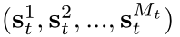
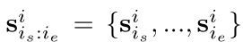
In general, multiple object tracking can be viewed as a multi-variable estimation problem. Given an image sequence, we employ to denote the state of the i -th object in the t-th frame, =
to denote states of all the 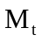 objects in the t -th frame. We employ
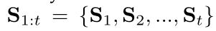
to denote the sequential states of the i-th object, where and are respectively the first and last frame in which target i exists, and
to denote all the sequential states of all the objects from the first frame to the t -th frame. Note that the object number may vary from frame to frame.

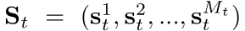
通常，可以将多目标跟踪视为多变量估计问题。 给定图像序列，我们使用来表示第t帧中第i个目标的状态，用 表示第t帧中所有M个目标的状态。
使用 表示第i个目标的连续状态（即在连续不同帧中的位置等

信息），和分别表示目标存在的第一帧和最后一帧。 表示从第1帧到第t帧所有目标的连续状态。注意目标数目在不同帧之间可能不同（因为有的帧可能不包含所有目标）（我认为这个S应该是目标的实际位置，状态）

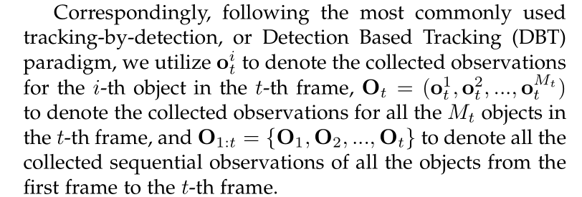

Correspondingly（相应的） paradigm（范例）

Correspondingly, following the most commonly used tracking-by-detection, or Detection Based Tracking (DBT) paradigm, we utilize（使用） to denote the collected observations for the i -th object in the t -th frame, 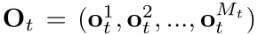
to denote the collected observations for all the 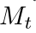 objects in the t -th frame, and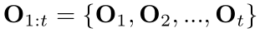 to denote all the collected sequential （连续的）observations of all the objects from the first frame to the t -th frame.

相应地，遵循最常用的通过检测进行跟踪或基于跟踪的检测（DBT）范例，我们利用来表示第t帧中第i个目标的收集观测值，使用表示第t帧中所有的个目标的观测值。表示从第1帧到第t帧收集到的所有物体连续的观测值。（我认为这个O应该是目标的观测位置，预测位置或状态）

The objective of multiple object tracking is to find the “optimal” sequential states of all the objects, which can be generally modeled by performing（执行） MAP (maximum a posteriori) estimation from the conditional （条件）distribution （分布）of the sequential states given all the observations:

多目标跟踪的目的是找到所有对象的“最佳”连续状态，通常可以通过在给定所有观察的情况下从连续状态的条件分布（概率术语！）执行MAP（最大后验概率）估计来建模：

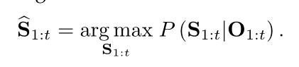
公式什么意思？？？ 在观测到的目标中真实存在目标的概率
https://zhidao.baidu.com/question/51351101.html
https://en.wikipedia.org/wiki/Arg_max

Different MOT algorithms from previous works can now be thought as designing different approaches to solving the above MAP problem, either from a probabilistic （概率性的）inference perspective [6], [31], [32], [33], [34], [35], [36], [37] or a deterministic （确定性的）optimization perspective [16], [38], [39], [40], [41], [42], [43], [44], [45], [46], [47], [48].

现在可以将以前工作中的不同MOT算法设想为设计解决上述MAP问题的不同方法。一部分从概率推理的角度来看如[6]，[31]，[32]，[33]，[34]，[35] ，[36]，[37]，另一部分从确定性优化视角[16]，[38]，[39]，[40]，[41]，[42]，[43]，[44]，[45]，[ 46]，[47]，[48]。

The probabilistic inference based approaches usually solve the MAP problem in Eqn. (1) using a two-step iterative procedure as follows,

基于概率推理的方法通常解决方程式中的MAP问题。 （1）使用如下的两步迭代程序，

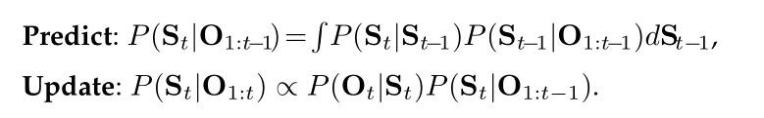

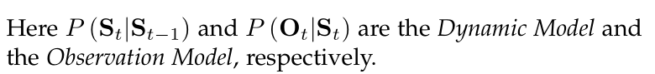

这里，P（S _{t} | S _{t-1}）和P（O _{t} | S _{t}）分别是动态模型和观测模型。

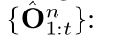
The deterministic optimization based approaches directly maximize the likelihood function L(O _{1:t} |S _{1:t} ) as a delegate（代表） of P (S _{1:t} |O _{1:t} ) over a set of available observations

基于确定性优化的方法直接最大化似然函数 L(O _{1:t} |S _{1:t} )作为P (S _{1:t} |O _{1:t} ) 在一组可用观测值 上的代表

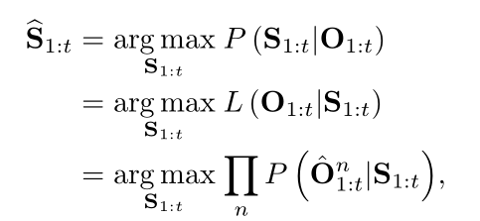
or conversely minimize an energy function E (S _{1:t} |O _{1:t} ) :

或者反过来最小化能量函数E (S _{1:t} |O _{1:t} ) : ？？？
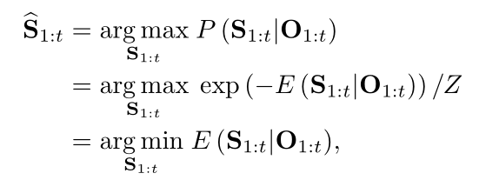

where Z is a normalization factor to ensure P (S _{1:t} |O _{1:t} ) to be a probability distribution.

其中Z是归一化因子，以确保 P (S _{1:t} |O _{1:t} )为概率分布。

2.2 MOT Categorization 多目标跟踪分类

It is difficult to classify one particular MOT method into a distinct（清楚地） category by a universal criterion（标准）. Admitting this, it is thus feasible（可行的） to group MOT methods by multiple criteria. In the following we attempt to conduct this according to three criteria: a) initialization method, b) processing mode, and c) type of output. The reason we choose these three criteria is that this naturally follows the way of processing a task, i.e., how the task is initialized, how it is processed and what type of result is obtained. In the following, each of the criteria（标准） along with its corresponding（相应的） categorization is represented.

通过通用标准很难将一种特定的MOT方法确切地为不同的类别。 因此，可以通过多个标准对MOT方法进行分组。 在下文中，我们尝试根据三个标准来执行此操作：a）初始化方法，b）处理模式，以及c）输出类型。 我们选择这三个标准的原因在于，这是处理任务的方式，即任务如何初始化，如何处理以及获得什么类型的结果。 在下文中，每个标准及其相应的分类将被详细地表示。

2.2.1 Initialization Method 初始化方法

Most existing MOT works can be grouped into two sets [49], depending on how objects are initialized: Detection-Based Tracking (DBT) and Detection-Free Tracking (DFT).

大多数现有的MOT工作可以分为两组[49]，具体取决于目标的初始化方式：基于检测的跟踪（DBT）和无检测跟踪（DFT）。

Detection-Based Tracking. As shown in Figure 1 (top), objects are first detected and then linked into trajectories. This strategy is also commonly referred to as “tracking-by-detection”. Given a sequence, type-specific object detection or motion detection (based on background modeling) [50], [51] is applied in each frame to obtain object hypotheses, then (sequential or batch) tracking is conducted to link detection hypotheses into trajectories. There are two issues worth noting. First, since the object detector is trained in advance, the majority of DBT focuses on specific kinds of targets, such as pedestrians, vehicles or faces. Second, the performance of DBT highly depends on the performance of the employed object detector.

基于检测的跟踪。 如图1（上方）所示，首先检测物体然后将其链接到轨迹中。 该策略通常也称为“基于检测跟踪”。 给定图像序列（视频），在每个帧中应用类型特定的目标检测或运动检测（基于背景建模）[50], [51]以获得目标假设（目标估计位置），然后进行（顺序或批量）跟踪以将检测假设链接到轨迹。 有两个值得注意的问题。 首先，由于目标探测器（往往针对的是特定物体）是预先训练的，因此大多数DBT专注于特定种类的目标，例如行人，车辆或面部。 其次，DBT的性能高度依赖于所用目标检测器的性能。
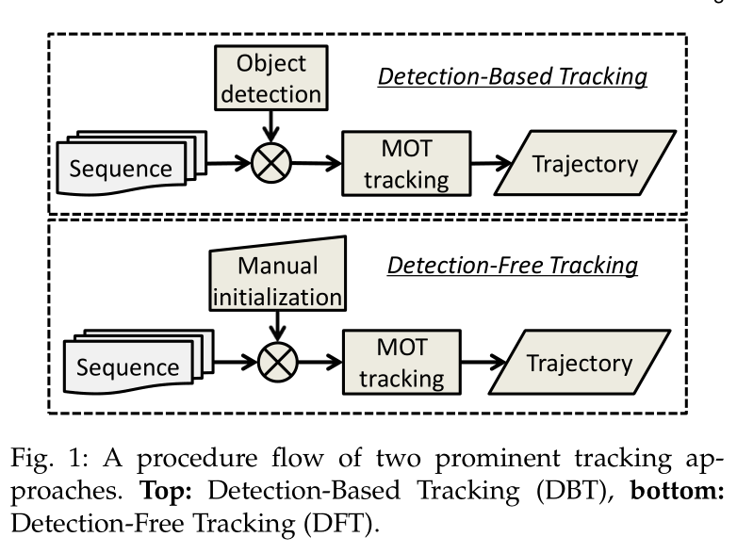

A procedure flow（流程） of two prominent tracking approaches（典型的跟踪方法）. Top: Detection-Based Tracking (DBT), bottom: Detection-Free Tracking (DFT).
图1：两种典型跟踪方法的程序流程。 上方：基于检测的跟踪（DBT），下方：无检测跟踪（DFT）。

Detection-Free Tracking. As shown in Figure 1 (bottom), DFT [52], [53], [54], [55] requires manual initialization of a fixed number of objects in the first frame, then localizes these objects in subsequent frames.

无检测跟踪。 如图1（下方）所示，DFT [52]，[53]，[54]，[55]需要在第一帧中手动初始化固定数量的目标，然后在后续帧中定位这些目标。

DBT is more popular because new objects are discovered and disappearing objects are terminated automatically. DFT cannot deal with the case that objects appear. However, it is free of pre-trained object detectors. Table 3 lists the major differences between DBT and DFT.

DBT更受欢迎，因为它可以自动发现新目标并且自动终止消失的目标。 DFT无法处理新目标出现的情况。 但是，它没有预先训练的物体探测器。 表3列出了DBT和DFT之间的主要差异。

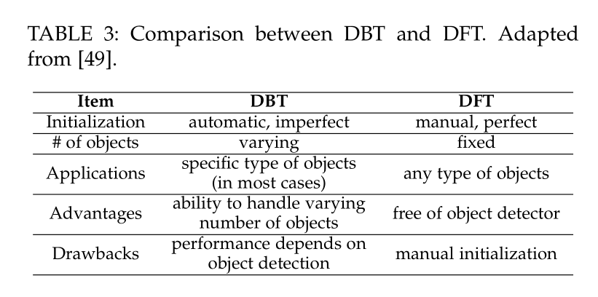
根据参考资料[49]得出的结论：DBT和DFT之间的比较

初始化方式 自动的，不完美的 手动的，完美的

目标 多样的 固定的

应用 特定目标（在大多数情况下） 任意目标

优点 可以检测各种数量的目标 不需要训练检测器

缺点 检测效果取决于物体检测器 手动初始化

2.2.2 Processing Mode 处理模式

MOT can also be categorized into online tracking and offline tracking. The difference is whether or not observations from future frames are utilized when handling the current frame. Online, also called causal, tracking methods only rely on the past information available up to the current frame, while offline, or batch tracking approaches employ observations both in the past and in the future.

上下文依赖：MOT还可以分为在线跟踪和离线跟踪。 不同之处在于在处理当前帧时是否使用来自未来帧的观测。 在线（也称为因果）跟踪方法仅依赖于当前帧之前可用的过去信息，而离线或批量跟踪方法使用之前或之后帧的观测结果。

Online tracking. In online tracking [52], [53], [54], [56], [57], the image sequence is handled in a step-wise（步进式） manner（方式）, thus online tracking is also named as sequential tracking. An illustration（图片） is shown in Figure 2 (top), with three objects (different circles) a, b, and c. The green arrows（箭头） represent observations in the past. The results are represented by the object’s location and its ID. Based on the up-to-time observations, trajectories are produced on the fly（立即）.

在线跟踪： 在线跟踪（[52]，[53]，[54]，[56]，[57]），图像序列以步进方式处理，因此在线跟踪也称为顺序跟踪。 如图2（上方），其中有三个目标（不同的圆圈）a，b和c。 绿色箭头表示过去的观测结果。 结果由目标的位置及其ID表示。 基于最新观测结果，轨迹是即时生成的。

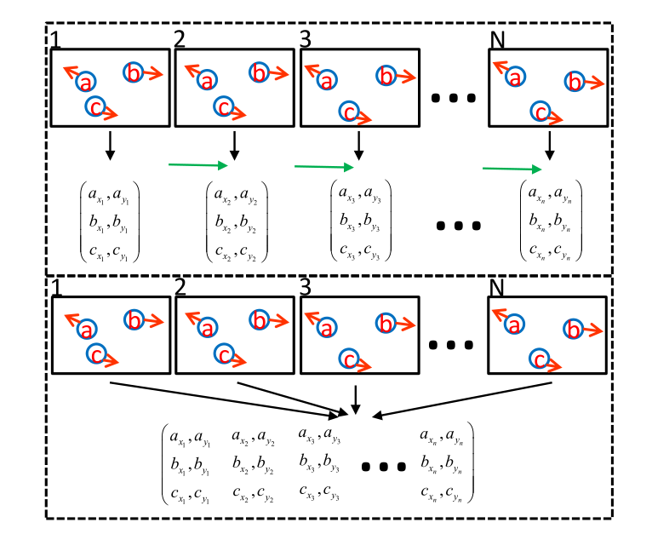
Fig. 2: An illustration of online (top) and offline (bottom) tracking. Best viewed in color.

图2：在线（top）和离线（bottom）跟踪的图示。

Offline tracking. Offline tracking [1], [46], [47], [51], [58], [59], [60], [61], [62], [63] utilizes a batch of frames to process the data. As shown in Figure 2 (bottom), observations from all the frames are required to be obtained in advance and are analyzed jointly（共同地） to estimate the final output. Note that, due to computational and memory limitation, it is not always possible to handle all the frames at once. An alternative solution is to split the data into shorter video clips, and infer（推断） the results hierarchically（分层地） or sequentially for each batch. Table 4 lists the differences between the two processing modes.
离线跟踪： 离线跟踪（[1]，[46]，[47]，[51]，[58]，[59]，[60]，[61]，[62]，[63]）利用一批帧来处理数据。 如图2（下方）所示，需要提前获得所有帧的观测值，并联合分析以估算最终输出。 请注意，由于计算和内存限制，并不总是能够一次处理所有帧。另一种解决方案是将数据拆分为较短的视频剪辑，并按层次或顺序推断每个批次的结果。表4列出了两种处理模式之间的差异。

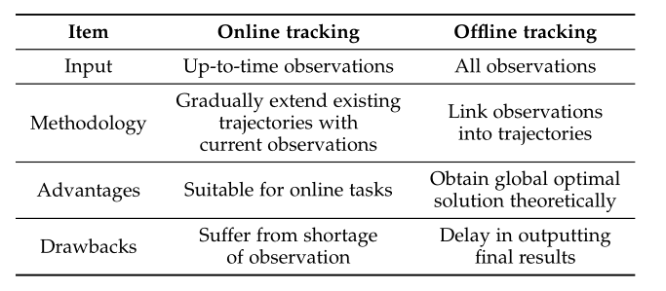

TABLE 4: Comparison between online and offline tracking
（在线跟踪和离线跟踪两种模式的比较）

Methodology 方法论

输入： 实时观测 所有观测

方法： 通过现有观测逐渐扩展现有轨迹 将观察结果链接到轨迹

优点： 适合在线任务 理论上获得全局最优解

缺点 受到观测不足的困扰 延迟输出最终结果

2.2.3 Type of Output 输出类型

This criterion classifies MOT methods into deterministic ones and probabilistic ones, depending on the randomness of output. The output of deterministic tracking is constant when running the methods multiple times. While output results are different in different running trials（试验） of probabilistic tracking methods. The difference between these two types of methods results from the optimization methods adopted as mentioned in Section 2.1.

该标准根据输出的随机性将MOT方法分为确定方法和概率方法。 当多次运行方法时，确定方法跟踪的输出是恒定的。 然而输出结果在概率跟踪方法的不同运行试验中是不同的。这两种方法之间的差异来自第2.1节中提到的优化方法。

2.2.4 Discussion 讨论

The difference between DBT and DFT is whether a detection model is adopted (DBT) or not (DFT). The key to differentiate online and offline tracking is the way they process observations. Readers may question whether DFT is identical to online tracking because it seems DFT always processes observations sequentially. This is true in most cases although some exceptions exist. Orderless tracking [64] is an example. It is DFT and simultaneously（同时地） processes observations in an orderless way（？？）. Though it is for single object tracking, it can also be applied for MOT, and thus DFT can also be applied in a batch mode. Another vagueness（模糊） may rise between DBT and offline tracking, as in DBT tracklets or detection responses are usually associated in a batch way. Note that there are also sequential DBT which conducts association between previously obtained trajectories and new detection responses [8], [31], [65].

DBT和DFT之间的区别在于是否采用检测模型（DBT 采用）（DFT 不采用）。 区分在线和离线跟踪的关键是他们处理观测的方式。 读者可能会质疑DFT是否与在线跟踪相同，因为DFT似乎总是按顺序处理观察。 在大多数情况下都是如此，不过还是存在一些例外。 无序跟踪[64]就是一个例子，它在一个无序跟踪方式里使用DFT和实时观测处理。 虽然它是用于单个目标跟踪，但也可以应用于MOT，因此DFT可以应用于批处理模式。 DBT和离线跟踪的界限也较为模糊，因为在DBT跟踪或检测响应通常以批处理方式关联。 注意，存在以顺序方式对先前获得的轨迹和新的检测响应之间建立关联的DBT，如[8]，[31]，[65]。

The categories presented above in Section 2.2.1, 2.2.2 and 2.2.3 are three possible ways to classify MOT methods, while there may be others. Notably, specific solutions for sport scenarios [5], [6], aerial scenes [44], [66], generic objects [8], [65], [67], [68], etc. exist and we suggest the readers refer to the respective publications.

上面第2.2.1, 2.2.2和2.2.3节中介绍的类别是对MOT方法进行分类的三种可能方法，而可能还有其他方法。 值得注意的是，存在运动场景[5]，[6]，空中场景[44]，[66]，通用对象[8]，[65]，[67]，[68]等的具体解决方案，我们建议读者可参阅各自的出版物。

By providing these three criteria described above, it is convenient for one to tag a specific method with the combination of the categorization label. This would help one to understand a specific approach easier.

通过提供上述这三个标准，方便的是用分类标签的组合标记特定方法。这将有助于人们更容易理解特定方法。

3 MOT COMPONENTS 多目标跟踪组成部分

In this section, we represent the primary components of an MOT approach. As mentioned above, the goal of MOT is to discover multiple objects in individual frames and recover the identity information across continuous frames, i.e., trajectory, from a given sequence. When developing MOT approaches, two major issues should be considered. One is how to measure similarity between objects in frames, the other one is how to recover the identity information based on the similarity measurement between objects across frames. Roughly speaking, the first issue involves the modeling of appearance, motion, interaction, exclusion, and occlusion. The second one involves with the inference problem. We review recent progress regarding both items as the following.

在本节中，我们描述了MOT方法的主要组成部分。 如上所述，MOT的目标是在各个帧中发现多个目标，并从给定序列的连续帧中（即轨迹）恢复身份信息。在探究MOT方法时，应考虑两个主要问题。一个是如何度量帧中目标之间的相似性，另一个是如何基于不同帧间目标之间的相似性度量来恢复身份信息。粗略地说，第一个问题涉及外观，运动，交互，排斥和遮挡的建模。 第二个涉及推理问题。我们将在接下来回顾有关这两个项目的最新进展。

3.1 Appearance Model 外观模型

Appearance is an important cue for affinity（密切关系） computation in MOT. However, different from single object tracking, which primarily focuses on constructing a sophisticated（复杂） appearance model to discriminate（区分） object from background, most MOT methods do not consider appearance modeling as the core component, although it can be an important one.

外观是MOT中关系计算的重要线索。 然而，与单个对象跟踪（主要侧重于构建复杂外观模型以区分目标和背景）不同，大多数MOT方法不将外观建模视为核心组件，尽管它可能是重要的。

Technically, an appearance model includes two components: visual representation and statistical measuring. Visual representation describes the visual characteristics of an object using some features, either based on a single cue or multiple cues. Statistical measuring, on the other hand, is the computation of similarity between different observations. More formally, the similarity between two observations i and j can be written as
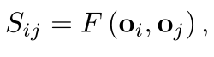
where o _{i} and o _{j} are visual representations of different observations, and F (·,·) is a function that measures the similarity between them. In the following, we first discuss the visual representation in MOT, and then describe statistical measurement, respectively.

从技术上讲，外观模型包括两个组成部分：视觉表示和统计测量。 视觉表示使用某些特征描述目标的视觉特征，基于单个条件或多个条件。 另一方面，统计测量是不同观测结果之间的相似性的计算。 更正式地，两个观察i和j之间的相似性可以写为
其中o _{i}和o _{j}是不同观测的视觉表示，F（·，·）是测量它们之间相似性的函数。 在下文中，我们首先讨论MOT中的视觉表示，然后描述统计测量情况。

3.1.1 Visual Representation 视觉表示

Visual representation describes an object according to different kinds of features, which are shown in Figure 3. We group features into the following different categories.

视觉表示根据不同类型的特征描述对象，如图3所示。我们将特征分为以下不同类别。
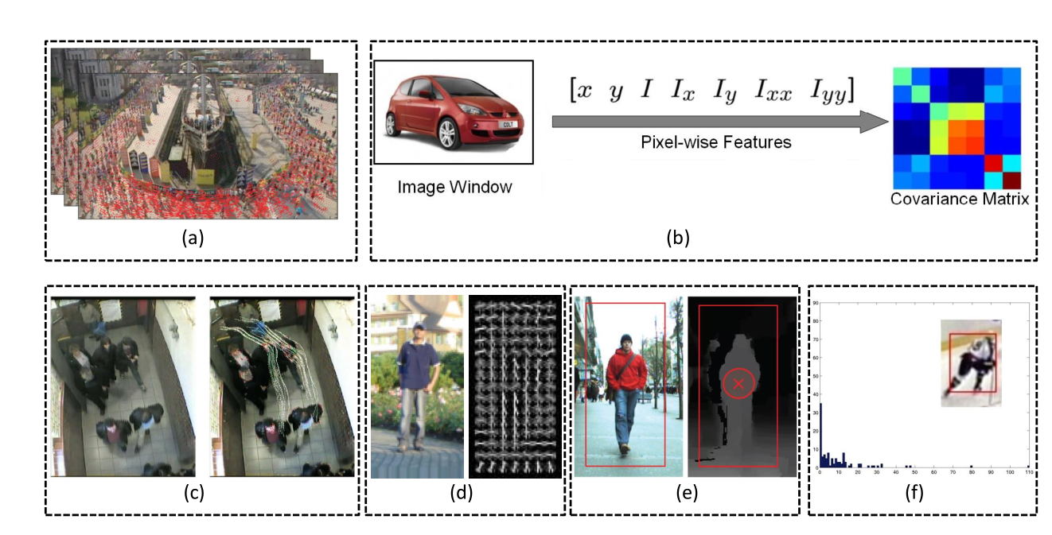
Fig. 3: An illustration of various visual features. (a) Optical flow [69], (b) covariance matrix, (c) point features [68], (d) gradient based features (HOG) [70], (e) depth [71], and (f) color features [72]. Best viewed in color.

图3：各种视觉特征的图示。 （a）光流[69]，（b）协方差矩阵，（c）点特征[68]，（d）基于梯度的特征（HOG）[70]，（e）深度[71]和（f）颜色特征[72]。

Local features. KLT is an example of searching “good” local features and tracking. It is successfully adopted in both SOT [73] and MOT. Obtaining easy-to-track features, we can employ them to generate short trajectories [62], [74], estimate camera motion [63], [75], motion clustering [68] and so on. Optical（光学的） flow can also be regarded as local features if we treat image pixel as the finest local range. A set of solutions to MOT utilize optical flow to link detection responses into short tracklets before data association [76], [77].As it is related with motion, it is utilized to encode motion information [78], [79]. One special application of optical flow is to discover crowd motion patterns in extremely crowded scenarios [35], [69], where ordinary features are not reliable.

局部特征。 KLT（光流法）是一个搜索局部特征并进行跟踪的不错的例子。 它在SOT [73]和MOT中都被成功采用。 获得易于跟踪的特征，我们可以使用它们来生成短轨迹[62]，[74]，估计相机运动[63]，[75]，运动聚类[68]等等。 如果我们将图像像素视为最精细的局部范围，则光流也可以被视为局部特征。 MOT的一些解决方案利用光流法在数据关联之前将检测链接到短轨迹[76]，[77]。由于它与运动有关（注意光流法需要目标的运动），因此用于编码运动信息[78]，[79]。 光流法的一个特殊应用是在非常拥挤的场景中发现人群运动模式[35]，[69]，而这种情景下普通特征是不可靠的。

Region features（区域特征）. Compared with local features, region features are extracted from a wider range (e.g. a bounding box). We illustrate（举例，说明） them as three types: a) zero-order type, b) first-order type and c) up-to-second-order type. Here, order means the order of discrepancy（矛盾，差异） when computing the representation（？？）. For instance, zero-order means values of pixels are not compared, while one-order means discrepancy values among pixels are computed once.

区域特征。与局部特征相比，区域特征从更宽范围（例如边界框）提取区域特征。 我们将它们描述为三种类型：a）零阶类型，b）一阶类型和c）二阶类型。 这里，order表示计算表示时的差异情况（？？）。 例如，零阶意味着像素的值不被比较，而一阶意味着像素之间的差异值被计算一次。

Zero-order. This is the most widely utilized representation for MOT. Color histogram [34], [62], [71],[72], [77] and raw pixel template [80] are two typical examples of this type.

零阶。这是MOT最广泛使用的表示。颜色直方图[34]，[62]，[71]，[72]，[77]和原始像素模板[80]是这种类型的两个典型示例。

First-order. Gradient-based representations like HOG [18], [32], [60], [77], [81] and level-set formulation [71] are commonly employed.

一阶。 通常采用基于梯度的表示，如HOG [18]，[32]，[60]，[77]，[81]和水平集公式[71]。

水平集
https://blog.csdn.net/limax_2004/article/details/3628163

Up-to-second-order. Region covariance matrix [82],[83] which computes up-to-second-order discrepancy belongs to this set. It has been adopted in [52], [60], [61].

二阶。 计算二阶差异的区域协方差矩阵[82]，[83]。 它已在[52]，[60]，[61]中得到采用。

Others. Besides local and region features, there are some other kinds of representation. Taking depth as an example, it is typically used to refine（改善） detection hypotheses [71], [84], [85], [86], [87]. The Probabilistic Occupancy Map (POM) [42], [88] is employed to estimate how likely an object would occur in a specific grid cell. One more example is gait feature, which is unique for individual persons [62].

其他：除了局部特征和区域特征外，还有其他一些表现形式。 以深度为例，它通常用于改进检测假设[71]，[84]，[85]，[86]，[87]。 概率占用图（POM）[42]，[88]用于估计目标在特定网格单元中出现的可能性。 另一个例子是步态特征，这对于个人（检测）来说是独一无二的[62]。

Discussion. Generally, color histogram is a well studied similarity measure, but it ignores the spatial（空间） layout（布局） of the object region. Local features are efficient, but sensitive to issues like occlusion and out-of-plane rotation. Gradient based features like HOG can describe the shape of an object and are robust（强健的，鲁棒的） to certain transformations such as illumination changes, but they cannot handle occlusion and deformation well. Region covariance matrix features are more robust as they take more information in account, but this benefit is obtained at the cost of more computation. Depth features make the computation of affinity more accurate, but they require multiple views of the same scenery and/or additional algorithm [89] to obtain depth measurements.

讨论： 通常，颜色直方图是一种经过充分研究的相似性度量，但它忽略了目标区域的空间布局。局部特征是有效的，但对遮挡和平面外旋转等问题很敏感。 基于梯度的特征（如HOG）可以描述目标的形状，并且对某些变换（如光照变化）具有鲁棒性，但它们无法很好地处理遮挡和变形。 区域协方差矩阵特征更加健壮，因为它们考虑了更多信息，但这种好处是以更多计算为代价获得的。深度特征使得相关度的计算更准确，但是它们需要相同场景的多个视图和附加算法[89]以获得深度测量。

3.1.2 Statistical Measuring 统计测量

This step is closely related to the section above. Based on visual representation, statistical measure computes the affinity between two observations. While some approaches solely rely on one kind of cue, others are built on multiple cues.

此步骤与上述部分密切相关。 基于视觉表示，统计测量计算两个观察之间的关联度（亲和力）。有些方法仅依赖于一种条件，还有些其他方法则是建立在多种条件之上的。

Single cue. Modeling appearance using single cue is either transforming distance into similarity or directly calculating the affinity. For example, the Normalized Cross Correlation (NCC) is usually adopted to calculate the affinity between two counterparts（对应物） based on the representation of raw pixel template mentioned above [2], [69], [80], [90]. Speaking of color histogram, Bhattacharyya distance B (·,·) is used to compute the distance between two color histograms c _{i} and c _{j} . The distance is transformed into similarity S like S (T i ,T j ) = exp(−B (c _{i} ,c _{j} )) [31], [36], [58], [62], [63], [91] or fit the distance to Gaussian distributions like [38]. Transformation of dissimilarity into likelihood is also applied to the representation of covariance matrix [61]. Besides these typical models, bag-of-words model [92] is employed based on point feature representation [33].

单一条件： 使用单个条件建模外观是将距离转换为相似性或直接计算相关度。 例如，通常采用归一化互相关（NCC）来计算两个对应物之间的相关度，基于上面提到的原始像素模板（[2]，[69]，[80]，[90]）来表示。说到颜色直方图，Bhattacharyya距离B（·，·）用于计算两个颜色直方图c _{i}和c _{j}之间的距离。 距离被转换为相似性S，如S（T _{i}，T _{j}）= exp（-B（c_{i}，c_{j}））[31]，[36]，[58]，[62]，[63]，[91] 或拟合高斯分布的距离，如[38]。 不相似性转化为似然性也适用于协方差矩阵的表示[61]。 除了这些典型的模型，基于点特征表示[33]采用词袋模型[92]。

Multiple cues. Different kinds of cues can complement each other to make the appearance model more robust.

多个条件。不同类型的条件可以相互补充，使外观模型更加健壮。

However, it not trivial to decide how to fuse the information from multiple cues. Regarding this, we summarize multicue based appearance models according to five kinds of fusion strategies: Boosting, Concatenating, Summation, Product, and Cascading (see also Table 5).

但是，决定如何融合来自多个线索的信息并非易事。对此，我们根据五种融合策略总结了基于多元的外观模型：Boosting，Concatenating，Summation，Product和Cascading（另见表5）。

TABLE 5: An overview of typical appearance models employing multiple cues
表5：采用多个条件的典型外观模型的概述

策略 使用的条件
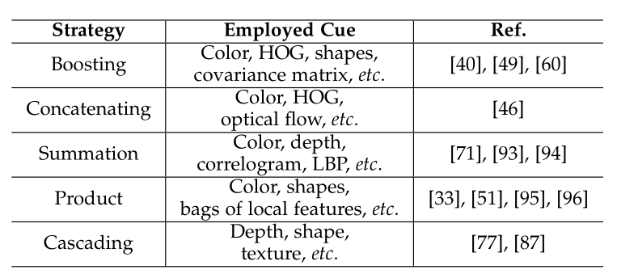

• Boosting. The strategy of Boosting usually selects a portion（部分） of features from a feature pool sequentially via a Boosting based algorithm. For example, from color histogram, HOG and covariance matrix descriptor, AdaBoost, RealBoost, and a HybridBoost algorithm are respectively employed to choose the most representative features to discriminate（区分） pairs of tracklets of the same object from those of different objects in [60], [49] and [40].（？？）

•Boosting: Boosting的策略通常通过基于Boosting的算法顺序地从特征池中选择一部分特征。 例如，从颜色直方图，HOG和协方差矩阵描述符，AdaBoost，RealBoost和HybridBoost算法分别被用于选择最具代表性的特征来从不同目标中区分出相同目标的轨迹（？？）。分别在 [60] AdaBoost, [49]RealBoost and [40] HybridBoost .

• Concatenation. Different kinds of features can be concatenated for computation. In [46], color, HOG and optical flow are concatenated for appearance modeling.

•Concatenation：不同类型的特征可以被连接起来用于计算。在[46]中，颜色，HOG和光流被连接起来用于外观建模。

• Summation. This strategy takes affinity values from different features and balance these values with weights [71], [93], [94].

• Summation. 该策略从不同特征中获取相关度值，并将这些值与权重进行平衡[71]，[93]，[94]。

• Product：Differently from the strategy above, values are multiplied to produce the integrated affinity [33],[51], [95], [96]. Note that, independence assumption is usually made when applying this strategy.

• Product：与上述策略不同，将值相乘以产生综合相关度[33]，[51]，[95]，[96]。 请注意，通常在应用此策略时会采用独立性假设。

• Cascading. This is a cascade manner of using various types of visual representation, either to narrow the search space [87] or model appearance in a coarse-to-fine way [77].

这是一种使用各种类型的视觉表示的级联方式，要么缩小搜索空间[87]，要么以一种由粗略到精细的方式模拟外观[77]。

3.2 Motion Model 运动模型

The motion model captures the dynamic behavior of an object. It estimates the potential position of objects in the future frames, thereby reducing the search space. In most cases, objects are assumed to move smoothly in the world and therefore in the image space (except for abrupt motions). We will discuss linear motion model and non-linear motion model in the following.

运动模型捕获目标的动态行为。 它估计了未来帧中目标的潜在位置，从而减少了搜索空间。 在大多数情况下，假设物体在世界中平滑移动，同理在图像空间中也这样移动（突然运动除外）。 我们将在下面讨论线性运动模型和非线性运动模型。

3.2.1 Linear Motion Model 线性运动模型

This is by far the most popular model [32], [97], [98]. A constant velocity assumption [32] is made in this model. Based on this assumption, there are three different ways to construct the model.

这是迄今为止最受欢迎的模型[32]，[97]，[98]。 在该模型中进行恒定速度假设[32]。 基于此假设，构建模型有三种不同的方法。

• Velocity smoothness is modeled by enforcing the velocity values of an object in successive frames to change smoothly. In [45], it is implemented as a cost term（？？）,

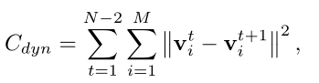

where the summation is conducted over N frames and M trajectories/objects.

•通过使用连续帧中目标平滑变化的速度值来建模一个平滑变化的速度。 在[45]中，它是作为代价函数实现的，

其中总和是建立在N个帧和M个轨迹（目标）上的

• Position smoothness directly forces（？？） the discrepancy（差异） between the observed position and estimated position. Let us take [31] as an example. Considering a temporal gap ∆t between tail of tracklet T _{j} and head of tracklet T _{j} , the smoothness is modeled by fitting the estimated position to a Gaussian distribution with the observed position as center. In the stage of estimation, both forward motion and backward motion are considered. Thus, the affinity considering linear motion model is,

位置平滑直接强制观察位置和估计位置之间的差异。 我们以[31]为例。考虑到轨迹T _{j} 的尾部与轨迹T _{j} 的头部之间存在时间间隙∆t，通过将估计的位置拟合为以观测位置为中心的高斯分布来建模平滑度。在估计阶段，考虑前向运动和后向运动。因此，考虑线性运动模型的相关性是，

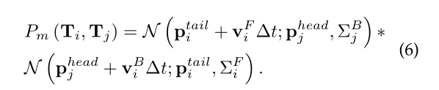

where “F” and “B” means forward and backward direction. A similar strategy is adopted by Yang et al. [59]. The displacement（位移） between observed position and estimated position ∆p is fit to a Gaussian distribution with zero center. Other examples of this strategy are [1], [7], [58], [59], [60], [99].

其中“F”和“B”表示前后方向。 Yang等人采用了类似的策略。[59]。观察位置和估计位置之间的位移∆p适合于以零中心的高斯分布。 该策略的其他例子是[1]，[7]，[58]，[59]，[60]，[99]。

• Acceleration smoothness. Besides considering position and velocity smoothness, acceleration is taken into account [99]. The probability distribution of motion of a state 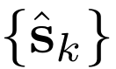 at time k given the observation tracklet {o _{k} } is modeled as,

•加速平滑。除了考虑位置和速度平滑之外，还要考虑加速度[99]。 给定观察轨迹 {o _{k} } 的时刻k的状态的运动概率分布可以被建模为，
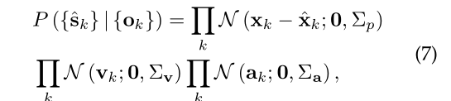

where v _{k} is the velocity, a _{k} is the acceleration, and N is a zero-mean Gaussian distribution.

其中v _{k} 是速度，a _{k}是加速度，N是零均值的高斯分布。

3.2.2 Non-linear Motion Model 非线性运动模型

The linear motion model is commonly used to explain the object’s dynamics. However, there are some cases which the linear motion model cannot deal with. To this end, non-linear motion models are proposed to produce more accurate motion affinity between tracklets. For instance, Yang et al. [47] employ a non-linear motion model to handle the situation that targets may move freely. Given two tracklets T ₁ and T ₂ which belong to the same target in Figure 4(a), the linear motion model [59] would produce a low probability to link them. Alternatively, employing the non-linear motion model, the gap between the tail of tracklet T ₁ and the head of tracklet T ₂ could be reasonably explained by a tracklet T ₀ ∈ S , where S is the set of support tracklets. As shown in Figure 4(b), T ₀ matches the tail of T ₁ and the head of T ₂ . Then the real path to bridge T ₁ and T ₂ is estimated based on T ₀ , and the affinity between T ₁ and T ₂ is computed similarly as described in Section 3.2.1.

线性运动模型通常已经可以解释目标的动态性。但是，有些情况下线性运动模型无法处理。为此，非线性运动模型被提出，以在轨迹之间产生更准确的运动相关性。 例如，杨等人。 [47]采用非线性运动模型来处理目标可以自由移动的情况。 给定两个轨迹T ₁ 和 T ₂属于图4（a）中的相同目标，线性运动模型[59]将对它们之间的联系给出一个极小的概率。然而，采用非线性运动模型，轨迹T ₁ 的尾部与轨迹 T ₂的头部之间的间隙可以通过轨迹 T ₀ ∈S合理地解释，其中S是支撑轨迹集合。 如图4（b）所示， T ₀ 匹配T ₁ 的尾部和 T ₂的头部。 然后基于 T ₀ 估计连接T ₁ 和T ₂的实际路径，并且使用类似于部分3.2.1中所述的方法计算T ₁ 和 T ₂之间的相关度。

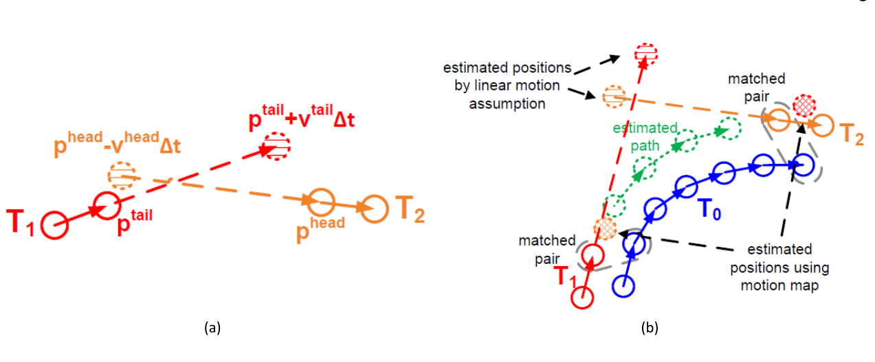

Fig. 4: An image comparing the linear motion model (a) with the non-linear motion model (b) [47].
图4：比较线性运动模型（a）和非线性运动模型（b）[47]的图像。

3.3 Interaction Model 交互模型

Interaction model, also known as mutual motion model, captures the influence of an object on other objects. In the crowd scenery, an object would experience some “force” from other agents and objects. For instance, when a pedestrian is walking on the street, he would adjust his speed, direction and destination, in order to avoid collisions with others. Another example is when a crowd of people walk across a street, each of them follows other people and guides others at the same time. In fact, these are examples of two typical interaction models known as the social force models [100] and the crowd motion pattern models [101].

交互模型，也称为相互运动模型，捕获一个目标对其他目标的影响。 在人群场景中，物体会受到来自其他媒介和物体的某种“力”。例如，当行人在街上行走时，他会调整他的速度，方向和目的地，以避免与他人发生碰撞。 另一个例子是当一群人走过一条街时，他们每个人都跟随其他人并同时引导其他人。实际上，这些是两种典型的交互模型的例子，称为社会力模型[100]和人群运动模式模型[101]。

3.3.1 Social Force Models 社会力模型

Social force models are also known as group models. In these models, each object is considered to be dependent on other objects and environmental factors. This type of information could alleviate（缓解） performance deterioration（恶化） in crowded scenes. In social force models, targets are considered as agents which determine（决定） their velocity, acceleration, and destination based on observations of other objects and the environment. More specifically, in social force models, target behavior is modeled based on two aspects, individual force and group force.

社会力模型也称为群体模型。在这些模型中，每个物体被认为依赖于其他物体和环境因素。这种类型的信息可以缓解拥挤场景中的性能恶化。在社会力模型中，目标被视为一个代理人，它根据对其他物体和环境的观测来确定其速度，加速度和目的地。更具体地来说，在社会量模型中，目标的行为基于个体和群体两个方面来建模。

Individual force. For each individual in a group of multiple objects, two types of forces are considered:

Individual force. 对于一组多个目标中的每个个体，考虑两种类型的力：

• fidelity, which means one should not change his desired destination
•保真度：这意味着不应该改变他想要的目的地

• constancy, which means one should not suddenly change his momentum, including speed and direction
•持续性，这意味着不应该突然改变他的动力，包括速度和方向
Group force. For a whole group, three types of forces are considered:
对于整个群体，考虑三种类型的力量：

• attraction, which means individuals moving together as a group should stay close
• repulsion, which means that individuals moving together as a group should keep some distance away from others to make all members comfortable
• coherence, which means individuals moving together as a group should move with similar velocity

•吸引力，这意味着作为一个群体一起移动的人应该保持密切联系
•排斥力，这意味着作为一个群体一起移动的个人应该与其他人保持一定距离，以使所有成员都感到舒适
•连贯性，这意味着作为一个群体一起移动的个体应该以相似的速度移动

The majority（多数） of existing publications modeling interaction among objects with social force typically minimizes an energy objective, consisting of terms reflecting individual force and group force. Table 6 lists exemplar publications in the community which adopt social force models for interaction modeling.

大多数现有出版物在具有社会力量的物体之间建立交互模型时通常最小化能量目标，包括反映个体力量和群体力量的术语。表6列出了社区中采用社交力模型进行交互建模的示例性出版物。

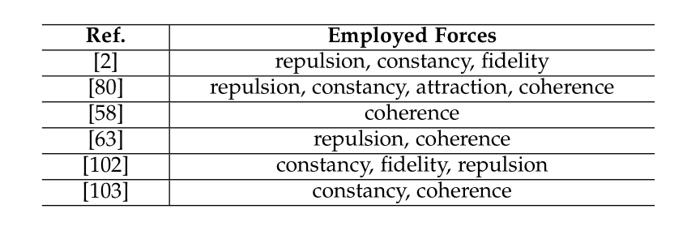
TABLE 6: Existing publications employing social force models.

使用社会力建模的现存出版物

3.3.2 Crowd Motion Pattern Models 人群运动模型

Inspired by the crowd simulation literature [23], motion patterns are introduced to alleviate the difficulty of tracking an individual object in the crowd. In general, this type of models is usually applied in the over-crowded scenario（方案，情况） where the density of targets is considerably high. In such highly-crowded scenery, objects are usually quite small, and cues such as appearance and individual motion are ambiguous. In this case, motion from the crowd is a comparably reliable cue for the problem.

受人群模拟文献[23]的启发，引入运动模式以降低在人群中追踪个体物体的难度。通常，这种类型的模型通常应用于目标密度相当高的过度拥挤的情况。 在如此高度拥挤的景物中，目标通常很小，并且诸如外观和个体运动之类的线索是模糊的。在这种情况下，来自人群的动作对于该问题是相对可靠的提示。

Roughly, there are two kinds of motion patterns, structured and unstructured ones. Structured motion patterns exhibit collective spatio-temporal structure while unstructured motion patterns exhibit various modalities of motion. In general, motion patterns are learned by various methods (including ND tensor voting [74], Hidden Markov Models [36], [104], Correlated Topic Model [76], sometimes considering scene structures [69]) and applied as prior knowledge to assist object tracking.

粗略地说，有两种运动模式，结构化和非结构化运动模式。结构化运动模式表现出集体时空结构，而非结构化运动模式表现出各种运动模态。一般来说，运动模式是通过各种方法学习的（包括ND张量投票[74]，隐马尔可夫模型[36]，[104]，相关主题模型[76]，有时考虑场景结构[69]）并作为先验知识应用 协助目标跟踪。

3.4 Exclusion Model 排除模型（感觉是对于多余的检测或多余的轨迹进行删减）

Exclusion is a constraint employed to avoid physical collisions when seeking a solution to the MOT problem. It arises from the fact that two distinct objects cannot occupy the same physical space in the real world. Given multiple detection responses and multiple trajectory hypotheses, generally there are two constraints. The first one is the socalled detection-level exclusion [105], i.e., two different detection responses in the same frame cannot be assigned to the same target. The second one is the so-called trajectory-level exclusion, i.e., two trajectories cannot be infinitely close to each other.

在寻求解决MOT问题时，排除是一个约束，用于避免物理冲突。 这是因为两个不同的物体不能在现实世界中占据相同的物理空间。给定多个检测响应和多个轨迹假设，通常存在两个约束。第一个是检测级别排除[105]，即，同一帧中的两个不同的检测响应不能分配给同一个目标。第二个是轨迹级排除，即两个轨迹不能彼此无限接近。

3.4.1 Detection-level Exclusion Modeling 检测级排除建模 （不懂）

Different approaches are adopted to model the detection-level exclusion. Basically, there are “soft” and “hard” models.

采用不同的方法来模拟检测级排除。基本上，有“软”和“硬”模型。

“Soft” modeling. Detection-level exclusion is “softly” modeled by minimizing a cost term to penalize（处罚） the case of violation（违反）. For example, a penalty is defined if two simultaneous detection responses are assigned the same label of trajectory and they are sufficiently distant from each other in [105].

“软”建模。 通过最小化代价处罚违反的情况来“softly”建模检测级别排除。 例如，如果两个同时检测响应被分配相同的轨迹标记并且它们中彼此足够远，则定义惩罚，如在[105]。

To model exclusion, a special exclusion graph is constructed to capture the constraint [106]. Given all the detection responses, they define a graph where nodes represent detection responses. Each node (one detection) is connected only to nodes (other detections) that exist at the same time as the node itself. After constructing this graph, the label assignment is maximized w.r.t. exclusion to encourage connected nodes to have different labels as Tr(YLY) （？？）, where L is the Laplacian matrix, Y =(y₁ ,...,y _{|V |}) is the label assignment of all the |V | nodes in the graph, and Tr(·) is the trace norm of a matrix.

为了模拟排除，构造了一个特殊的排除图来捕获约束[106]。 给定所有检测响应，它们定义了一个图表，其中节点表示检测响应。每个节点（一个检测）仅连接到与节点本身同时存在的节点（其他检测）。构建此图后，标签分配是最大化的，排除以鼓励连接节点具有不同的标签Tr(YLY)，其中L是拉普拉斯矩阵，Y =(y1，...，y | V |)是所有图中的节点| V |的标签分配，Tr(·)是矩阵的跟踪范数。

“Hard” modeling. “Hard” modeling of detection-level exclusion is implemented by applying explicit constraint. For instance, to model the detection-level exclusion, the so-called cannot links are introduced to imitate that if two tracklets have overlap in their time span, then they cannot be assigned to the same cluster, i.e. to belong to the same trajectory [107]. Non-negative discretization is conducted in [108] to set detections into non-overlapping groups to obey the constraint of mutual exclusion.

“硬”建模。 通过应用显式约束来实现检测级排除的“硬”建模。 例如，为了对检测级别排除进行建模，引入了所谓的无法链接来模仿如果两个轨迹在它们的时间跨度上有重叠，则它们不能被分配到同一个集群，即属于相同的轨迹[107]。 在[108]中进行非负离散化以将检测设置为非重叠组以遵守互斥约束。

3.4.2 Trajectory-level Exclusion Modeling 轨迹级排除建模

Generally, trajectory-level exclusion is modeled by penalizing the case that two close detection hypotheses have different trajectory labels. This will suppress one trajectory label. For example, the penalty term in [109] is inversely proportional to the distance between two detection responses with different trajectory labels. If two detection responses are too close, it will lead to a considerably large, or in the limit case, infinite, cost. Similar idea is adopted in [48]. On the contrary, the penalty of trajectory-level exclusion in [105] is proportional to the spatial-temporal overlap between two trajectories. The closer the two trajectories, the higher the penalty. There is also a special case [43], in which the exclusion is modeled as an extra constraint to the so-called “Conflict” edges in a network flow based algorithm.

通常，通过惩罚具有不同轨迹标签两个紧密检测假设的情况来建模轨迹水平排除（两个检测相挨紧密，但却属于不同轨迹标签，此时认为存在问题，利用代价公式进行惩罚运算）。这将抑制一个轨迹标签。例如，[109]中的惩罚项与具有不同轨迹标签的两个检测响应之间的距离成反比。如果两个检测响应太接近，则会导致相当大的成本，或者在极限情况下，无限的成本。在[48]中采用了类似的想法。相反，[105]中的轨迹水平排除的惩罚与两个轨迹之间的时空重叠成比例。 两条轨迹越近，惩罚越高。还有一个特殊情况[43]，其中排除被建模为基于网络流的算法中所谓的“冲突”边缘的额外约束。

3.5 Occlusion Handling 遮挡处理

Occlusion is perhaps the most critical challenge in MOT. It is a primary cause for ID switches or fragmentation of trajectories. In order to handle occlusion, various kinds of strategies have been proposed.

遮挡可能是MOT中最关键的挑战。它是ID切换或轨迹碎片的主要原因。为了处理遮挡，已经提出了各种策略。

3.5.1 Part-to-whole 部分到整体

This strategy is built on the assumption that a part of the object is still visible when an occlusion happens. This assumption holds in most cases. Based on this assumption, approaches adopting this strategy observe and utilize the visible part to infer the state of the whole object.

该策略建立在假设遮挡发生时对象的一部分仍然可见的基础上。在大多数情况下，这种假设成立。基于该假设，采用该策略的方法观察并利用可见部分来推断整个对象的状态。

The popular way is dividing a holistic object (like a bounding box) into several parts and computing affinity based on individual parts. If an occlusion happens, affinities regarding occluded parts should be low. Tracker would be aware of this and adopt only the unoccluded parts for estimation. Specifically, parts are derived by dividing objects into grids uniformly [52], or fitting multiple parts into a specific kind of object like human, e.g. 15 non-overlap parts as in [49], and parts detected from the DPM detector [110] in [77], [111].

流行的方法是将整体目标（如边界框）分成几个部分，并根据各个部分计算相关性。如果发生遮挡，则关于遮挡部分的相关性应该低。跟踪器会意识到这一点并仅采用未被遮挡的部分进行估算。具体地，通过将目标均匀地划分为网格[52]，或者将多个部分拟合到特定种类的物体（例如人类）。如[49]中的15个非重叠部分，以及[77]，[111]中的DPM检测器[110]检测到的部分。

Based on these individual parts, observations of the occluded parts are ignored. For instance, part-wise appearance model is constructed in [52]. Reconstructed error is used to determine which part is occluded or not. The appearance model of the holistic object is selectively updated by only updating the unoccluded parts. This is the “hard” way of ignoring the occluded part, while there is a “soft” way in [49]. Specifically, the affinity concerning two tracklets j and k is computed as

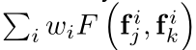

, where f is feature, i is the index of parts. The weights are learned according to the occlusion relationship of parts. In [77], human body part association is conducted to recover the part trajectory and further assists whole object trajectory recovery.

基于这些单独的部分，被遮挡部分的观测可以被忽略。例如，在[52]中构建了部分外观模型。重建误差被用于确定哪个部分被遮挡。通过仅更新未被遮挡的部分来选择性地更新整体目标的外观模型。这是忽略遮挡部分的“硬”方式，而[49]中存在“软”方式。 具体地，关于两个轨迹j和k的关联性被计算为

其中f是特征，i是各部分（一个物体被划分为多个部分）的索引。 根据部件
的遮挡关系学习权重。 在[77]中，进行人体各部分关联以恢复部分轨迹并进一步辅助整个物体轨迹恢复。

“Part-to-whole” strategy is also applied in tracking based on feature point clustering, which assumes feature points with similar motion should belong to the same object. As long as some parts of an object are visible, the clustering of feature point trajectories will work [62], [68], [112].

“部分到整体”策略也应用于基于特征点聚类的跟踪，其假设具有相似运动的特征点应属于同一对象。 只要对象的某些部分可见，特征点轨迹的聚类就会起作用[62]，[68]，[112]。

3.5.2 Hypothesize-and-test 假设和测试

This strategy sidesteps challenges from occlusion by hypothesizing proposals and testing the proposals according to observations at hand. As the name indicates, this strategy is composed of two steps, hypothesize and test.

该策略通过假设提案和根据手头观测结果测试提案来回避遮挡带来的挑战。顾名思义，这个策略由两个步骤组成，即假设和测试。

Hypothesize. Zhang et al. [38] generate（发生） occlusion hypotheses based on the occludable pair of observations, which are close and with similar scale. Assuming o _{i} is occluded by o _{j} , a corresponding occlusion hypothesis is 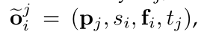
where p _{j} and t _{j} are the position and time stamp of o _{j} , and s _{i} and f _{i} are the size and appearance feature of o _{i} . This approach treats occlusion as distraction, while in other works [113], [114] occlusion patterns are employed to assist detection in case of occlusion. More specifically, different detection hypotheses are generated by synthetically（综合地） combining two objects with different levels and patterns of occlusion (see Figure 5).

假设：Zhang等人 [38]。基于可闭合的观测对产生遮挡的假设，这些观察结果接近且具有相似的比例。 假设o _{i} 被o _{j}遮挡，相应的遮挡假设是 其中p _{j} 和t _{j} 是o _{j} 的位置和时间标记，并且s _{i} 和f _{i}是o _{i} 的大小和外观特征。 这种方法将遮挡视为干扰，而在其他工作中[113]，[114]采用遮挡模式来辅助遮挡情况下的检测。更具体地，通过组合具有不同水平和遮挡模式的两个目标来生成不同的检测假设（参见图5）。

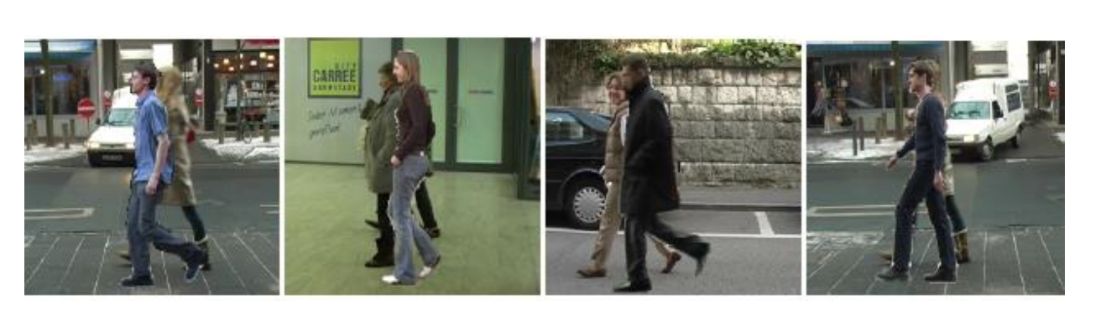
Fig. 5: Training samples for the double-person detector [113]. From left to right, the level of occlusion increases

图5：双人探测器的训练样本[113]。 从左到右，闭塞程度增加

Test. The hypotheses would be employed for MOT when they are ready. Let us revisit the two approaches described above. In [38], the hypothesized observations along with the original ones are given as input to the cost-flow framework and MAP is conducted to obtain the optimal solution. In [114] and [113], a multi-person detector is trained based on the detection hypotheses. This detector greatly reduces the difficulty of detection in case of occlusion.

测试：当准备就绪时，这些假设将被用于MOT。 让我们重新审视上述两种方法。 在[38]中，假设的观察结果与原始观察结果一起作为成本-流程框架的输入，并且进行MAP以获得最优解。 在[114]和[113]中，基于检测假设训练多人检测器。 该探测器大大降低了遮挡情况下的探测难度。

3.5.3 Buffer-and-recover 缓冲和恢复

This strategy buffers observations when occlusion happens and remembers states of objects before occlusion. When occlusion ends, object states are recovered based on the buffered observations and the stored states before occlusion.

该策略在发生遮挡时缓冲观察并在遮挡之前记住目标的状态。当遮挡结束时，基于缓冲的观察和遮挡之前存储的状态来恢复目标状态。

Mitzel et al. [71] keep a trajectory alive for up to 15 frames when occlusion happens, and extrapolates the position to grow the dormant trajectory through occlusion. In case the object reappears, the track is triggered again and the identity is maintained. This idea is followed in [34]. Observation mode is activated when the tracking state becomes ambiguous due to occlusion [115]. As soon as enough observations are obtained, hypotheses are generated to explain the observations. This could also be treated as “buffer-and-recover” strategy.

Mitzel等人。当发生遮挡时，保持轨迹活动多达15帧，并推断该位置以在遮挡时增长休眠轨迹。如果对象重新出现，则再次触发轨道并保持身份。这个想法在[34]被采纳。当跟踪状态由于遮挡而变得模糊时，观察模式被激活。[115] 一旦获得足够的观察结果，就会产生假设来解释观察结果。这也可以被视为“缓冲和恢复”策略。

3.5.4 Others 其他

The strategies described above may not cover all the tactics explored in the community. For example, Andriyenko et al. [116] represent targets as Gaussian distributions in image space and explicitly model pair-wise occlusion ratios between all targets as part of a differentiable energy function. In general, it is non-trivial to distinctly separate or categorize various approaches to occlusion modeling, and in some cases, multiple strategies are used in combination.

上述策略可能无法涵盖社区中的所有策略。 例如，Andriyenko等人[116]。将目标表示为图像空间中的高斯分布，并明确地模拟所有目标之间的成对遮挡比率，作为可微分能量函数的一部分。通常，将各种闭塞建模方法明确地分开或分类是非常重要的，并且在一些情况下，组合使用多种策略。

3.6 Inference 推论

3.6.1 Probabilistic Inference 概率推理

Approaches based on probabilistic inference typically represent states of objects as a distribution with uncertainty. The goal of a tracking algorithm is to estimate the probabilistic distribution of target state by a variety of probability reasoning methods based on existing observations. This kind of approaches typically requires only the existing, i.e. past and present observations, thus they are especially appropriate for the task of online tracking. As only the existing observations are employed for estimation, it is naturally to impose the assumption of Markov property in the objects state sequence. This assumption includes two aspects, recalling the formula in Section 2.1.

基于概率推理的方法通常将目标的状态表示为具有不确定性的分布。跟踪算法的目标是通过基于现有观察的各种概率推理方法来估计目标状态的概率分布。这种方法通常仅需要现有的，即过去和现在的观察，因此它们特别适合于在线跟踪的任务。由于仅使用现有的观察来进行估计，因此自然地将Markov属性的假设强加于对象状态序列中。这个假设包括两个方面，回顾2.1节中的公式。

First, the current object state only depends on the previous states. Further, it only depends on the very last state if the first-order Markov property is imposed, which can be formalized as P (S _{t} |S _{1:t−1} ) = P (S _{t} |S _{t−1} )
首先，当前目标状态仅取决于先前的状态。此外，如果施加一阶马尔可夫性质，它只取决于最后的状态（即之前所有状态的最后一个），可以形式化为P（S t | S 1：t-1）= P（S t | S t-1）

Second, the observation of an object is only related to its state corresponding to this observation. In other words, the observations are conditionally independent:

其次，目标的观察仅与其对应于该观察的状态有关。换句话说，观察是条件独立的：
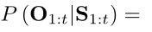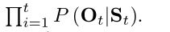

These two aspects are related to the Dynamic Model and the Observation Model, respectively. The dynamic model corresponds to the tracking strategy, while the observation model provides observation measurements concerning object states. The predict step is to estimate the current state based on all the previous observations. More specifically, the posterior probability distribution of the current state is estimated by integrating in the space of the last object state via the dynamic model. The update step is to update the posterior probability distribution of states based on the obtained measurements under the observation model.

这两个方面分别与动态模型和观察模型有关。动态模型对应于跟踪策略，而观察模型提供关于目标状态的观察测量。预测步骤是基于所有先前的观察来估计当前状态。更具体地，通过经由动态模型在最后一个目标状态的空间中进行积分来估计当前状态的后验概率分布。更新步骤是基于在观察模型下获得的测量来更新状态的后验概率分布。

According to the equations, states of objects can be estimated by iteratively conducting the prediction and updating steps. However, in practice, the object state distribution cannot be represented without simplifying assumptions, thus there is no analytical solution to computing the integral of the state distribution. Additionally, for multiple objects, the dimension of the sets of states is very large, which makes the integration even more difficult, requiring the derivation for approximate solutions.

根据等式，可以通过迭代地进行预测和更新步骤来估计目标的状态。然而，实际上，在不简化假设的情况下不能表示目标状态分布，因为没有分析解决方案来计算状态分布的积分。另外，对于多个目标，状态集的维度非常大，这使得集成更加困难，需要推导出近似解。

Various kinds of probabilistic inference models haves been applied to multi-object tracking [36], [95], [117], [118], such as Kalman filter [35], [37], Extended Kalman filter [34] and Particle filter [32], [33], [52], [93], [119], [120], [121], [122].

各种概率推理模型已应用于多目标跟踪[36]，[95]，[117]，[118]，如卡尔曼滤波[35]，[37]，扩展卡尔曼滤波[34]和粒子滤波器[32]，[33]，[52]，[93]，[119]，[120]，[121]，[122]。

Kalman filter. In the case of a linear system and Gaussian-distributed object states, the Kalman filter [37] is proved to be the optimal estimator. It has been applied in [35].

卡尔曼滤波器。在线性系统和高斯分布状态的情况下，卡尔曼滤波器[37]被证明是最优估计器。它已在[35]中得到应用。

Extended Kalman filter. To include the non-linear case, the extended Kalman filter is one possible solution. It approximates the non-linear system by a Taylor expansion [34].

扩展卡尔曼滤波器。为了包括非线性情况，扩展卡尔曼滤波器是一种可能的解决方案。 它通过泰勒展开近似于非线性系统[34]。

Particle filter. Monte Carlo sampling based models have also become popular in tracking, especially after the introduction of the particle filter [10], [32], [33], [52], [93], [119], [120], [121]. This strategy models the underlying distribution by a set of weighted particles, thereby allowing to drop any assumptions about the distribution itself [32], [33], [36], [93].

粒子滤波。蒙特卡罗基于采样的模型在跟踪中也变得很流行，特别是在引入粒子滤波器之后[10]，[32]，[33]，[52]，[93]，[119]，[120]，[121]。该策略通过一组加权粒子对基础分布进行建模，从而允许放弃关于分布本身的任何假设[32]，[33]，[36]，[93]。

3.6.2 Deterministic Optimization 确定性优化

As opposed to the probabilistic inference methods, approaches based on deterministic optimization aim to find the maximum a posteriori (MAP) solution to MOT. To that end, the task of inferring data association, the target states or both, is typically cast as an optimization problem. Approaches within this framework are more suitable for the task of offline tracking because observations from all the frames or at least a time window are required to be available in advance. Given observations (usually detection hypotheses) from all the frames, these types of methods endeavor to globally associate observations belonging to an identical object into a trajectory. The key issue is how to find the optimal association. Some popular and well-studied approaches are detailed in the following.

与概率推理方法相反，基于确定性优化的方法旨在找到MOT的最大后验（MAP）解。为此，推断数据关联，目标状态或两者的任务通常被视为优化问题。该框架内的方法更适合于离线跟踪的任务，因为需要预先提供来自所有帧或至少一个时间窗的观测。给定来自所有帧的观察（通常是检测假设），这些类型的方法努力将属于相同目标的观测全局地关联到轨迹中。 关键问题是如何找到最佳关联。下面详细介绍了一些流行且经过充分研究的方法。

Bipartite graph matching. By modeling the MOT problem as bipartite graph matching, two disjoint sets of graph nodes could be existing trajectories and new detections in online tracking or two sets of tracklets in offline tracking. Weights among nodes are modeled as affinities between trajectories and detections. Then either a greedy bipartite assignment algorithm [32], [111], [123] or the optimal Hungarian algorithm [31], [39], [58], [66], [124] are employed to determine the matching between nodes in the two sets.

二分图匹配。通过将MOT问题建模为二分图匹配，两个不相交的图节点集可以是在线跟踪中的现有轨迹和新检测或在离线跟踪中的两组轨迹。节点之间的权重被建模为轨迹和检测之间的相关性。然后采用贪心的二分分配算法[32]，[111]，[123]或最优匈牙利算法[31]，[39]，[58]，[66]，[124]来在两个节点集合中进行匹配。

Dynamic Programming. Extend dynamic programming [125], linear programming [126], [127], [128], quadratic boolean programming [129], K-shortest paths [18], [42], set cover [130] and subgraph multicut [131], [132] are adopted to solve the association problem among detections or tracklets.

动态编程。扩展动态编程[125]，线性编程[126]，[127]，[128]，二次布尔编程[129]，K-最短路径[18]，[42]，集合覆盖[130]和子图多核[131] ]，[132]用于解决检测或跟踪之间的关联问题。

Min-cost max-flow network flow. Network flow is a directed graph where each edge has a certain capacity. For MOT, nodes in the graph are detection responses or tracklets. Flow is modeled as an indicator to link two nodes or not. To meet the flow balance requirement, a source node and a sink node corresponding to the start and the end of a trajectory are added to the graph (see Figure 6). One trajectory corresponds to one flow path in the graph. The total flow transited from the source node to the sink node equals to the number of trajectories, and the cost of transition is the negative log-likelihood of all the association hypotheses. Note that the globally optimal solution can be obtained in polynomial time, e.g. using the push-relabel algorithm. This model is exceptionally popular and has been widely adopted [18], [38], [41], [43], [90], [133].

最低成本的最大流量网络流。网络流是有向图，其中每个边具有一定的容量。对于MOT，图中的节点是检测响应或跟踪。流被建模为链接或不链接两个节点的指示符（如int flow 链接 flow =1 不连接 flow=0）。为了满足流量平衡要求（进=出），将对应于轨迹的开始的源节点和结束的汇聚节点添加到图形中（参见图6）。一个轨迹对应于图中的一个流动路径。 从源节点转移到汇聚节点的总流量等于轨迹的数量，转换的成本是所有关联假设的负对数似然。注意，全局最优解可以在多项式时间内获得，例如，使用push-relabel算法。该模型非常受欢迎，并被广泛采用[18]，[38]，[41]，[43]，[90]，[133]。

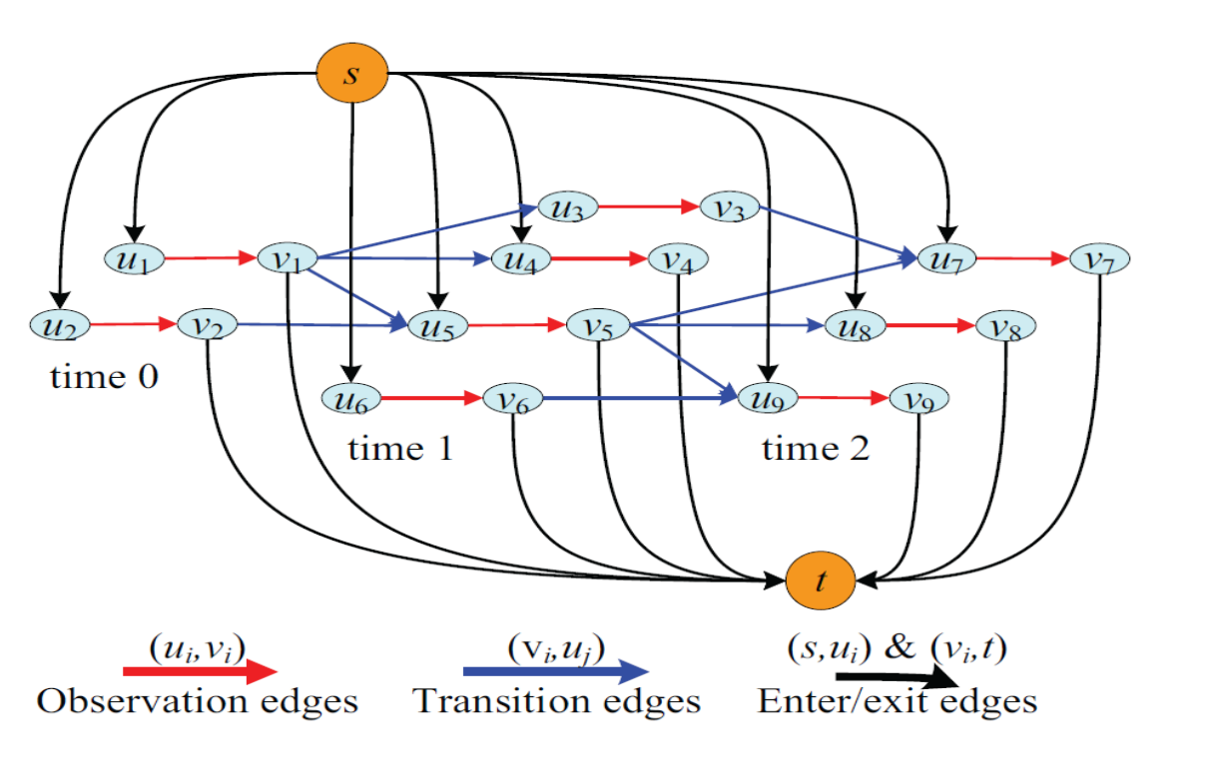
Fig. 6: The original cost-flow network of Zhang and Nevatia [38] with 3 timesteps and 9 observations.

图6：Zhang和Nevatia [38]的原始成本流网络，有3个时间步长和9个观测值。

Conditional random field. The conditional random field model is adopted to handle the MOT problem in [1], [59], [105], [134]. Defining a graph G = (V,E) where V is the set of nodes and E is the set of edges, low-level tracklets are given as input to the graph. Each node in the graph represents observations [105] or pairs of tracklets [59], and a label is predicted to indicate which track the observations belongs to or whether to link the tracklets.

条件随机场。采用条件随机场模型来处理[1]，[59]，[105]，[134]中的MOT问题。定义图G =（V，E）其中V是节点集，E是边集，低级轨迹作为图的输入。图中的每个节点代表检测[105]或轨迹对[59]，并且预测标签以指示检测属于哪个轨道或是否链接轨迹。

MWIS. The maximum-weight independent set (MWIS) is the heaviest subset of non-adjacent nodes of an attributed graph. As in the CRF model described above, nodes in the attribute graph represent pairs of tracklets in successive frames, weights of nodes represent the affinity of the tracklet pair, and the edge is connected if two tracklets share the same detection. Given this graph, the data association is modeled as the MWIS problem [46], [97].

最大权重独立集（MWIS）。最大权重独立集（MWIS）是属性图的非相邻节点的最大权重子集。如在上面描述的CRF模型中，属性图中的节点表示连续帧中的轨迹对，节点的权重表示轨迹对的相关度，并且如果两个轨迹共享相同的检测，则连接边缘。给定此图，数据关联被建模为MWIS问题[46]，[97]。

3.6.3 Discussion 讨论

In practice, deterministic optimization or energy minimization is employed more popularly compared with probabilistic approaches. Although the probabilistic approaches provide a more intuitive and complete solution to the problem, they are usually difficult to infer. On the contrary, energy minimization could obtain a “good enough” solution in a reasonable time.

在实践中，与概率方法相比，更普遍地采用确定性优化或能量最小化。虽然概率方法为问题提供了更直观和完整的解决方案，但它们通常很难推断。相反，能量最小化可以在合理的时间内获得“足够好”的解决方案。

4 MOT EVALUATION MOT评估

For a given MOT approach, metrics（指标） and datasets are required to evaluate its performance quantitatively. This is important for two reasons. On one hand, it is essential to measure the influence of different components and parameters on the overall performance to design the best system. On the other hand, it is desirable to have a direct comparison to other methods. Performance evaluation for MOT is not straightforward, as we will see in this section.

对于给定的MOT方法，需要指标和数据集来定量评估其性能。这有两个重要原因。一方面，必须衡量不同组件和参数对整体性能的影响，以设计出最佳系统。 另一方面，希望与其他方法直接比较。对MOT的性能评估并不简单，我们将在本节中看到。

4.1 Metrics 指标

Evaluation metrics of MOT approaches are crucial as they provide a means for fair quantitative comparison. A brief review on different MOT evaluation metrics is presented in this section. As many approaches to MOT employ the tracking-by-detection strategy, they often measure detection performance as well as tracking performance. Metrics for object detection are therefore adopted in MOT approaches. Based on this, MOT metrics can be roughly categorized into two sets evaluating detection and tracking respectively, as listed in Table 7.

MOT方法的评估指标至关重要，因为它们提供了公平量化比较的手段。本节介绍了有关不同MOT评估指标的简要回顾。由于MOT的许多方法都采用通过检测进行跟踪的策略，因此它们通常可以测量检测性能以及跟踪性能。因此，在MOT方法中采用用于物体检测的度量。基于此，MOT指标可以大致分为两组，分别评估检测和跟踪，如表7所示。

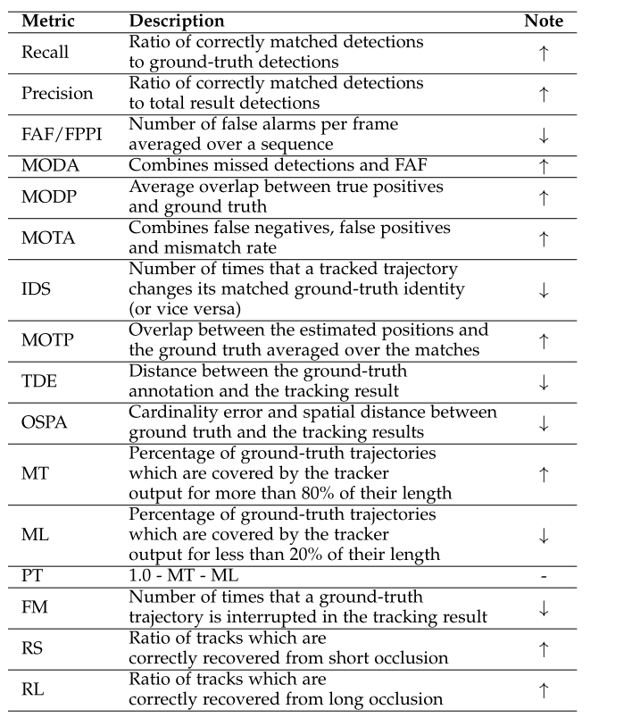
TABLE 7: An overview of evaluation metrics for MOT. The up arrow (resp. down arrow) indicates that the performance is better if the quantity is greater (resp. smaller).

表7：MOT的评估指标概述。向上箭头（分别向下箭头）表示如果数量更大（相应更小），性能会更好。

Recall（召回率）：正确的检测和所有真实目标标签的比率
Precision（准确率）：正确的检测和所有检测结果的比率
FAF/FPPI：在视频序列上平均每帧错误检测（警报）数 （漏检）
MODA：综合考虑漏检和错检（FAF）
MODP：True Positive（被预测为正的正样本）和真实目标标签的平均重叠比率
MOTA：综合考虑false negatives（假负，模型预测为负的正样本）false positives（模型预测为正的负样本）和错误匹配率
IDS：Number of times that a tracked trajectory changes its matched ground-truth identity (or vice versa)

跟踪轨迹改变其匹配的目标标签的次数（反之亦然）
（也就是说，原先轨迹对应的目标是A，过了一段时间这条轨迹对应的目标变成了B，这样就改变了一次）

MOTP：Overlap between the estimated positions and the ground truth averaged over the matches

在匹配中模型的预测位置和目标的实际位置的平均重叠率

TDE：Distance between the ground-truth annotation（注释） and the tracking result

目标位置标注和跟踪结果之间的距离

OSPA：Cardinality（基数） error and spatial（空间的） distance between ground truth and the tracking results

跟踪结果和目标实际位置之间的基数误差和空间距离

MT：Percentage of ground-truth trajectories which are covered by the tracker output for more than 80% of their length

跟踪器输出跟踪结果与实际标注结果覆盖率大于80%的数据占所有数据的百分比

ML：Percentage of ground-truth trajectories which are covered by the tracker output for less than 20% of their length

跟踪器输出跟踪结果与实际标注结果覆盖率小于20%的数据占所有数据的百分比

PT: 1.0 - MT - ML

FM: Number of times that a ground-truth trajectory is interrupted in the tracking result

实际标注目标在跟踪结果中被中断的次数（如何才能被中断？）

RS：Ratio of tracks which are correctly recovered from short occlusion

可以从短暂遮挡中正确恢复的轨道比率

RL：Ratio of tracks which are correctly recovered from long occlusion

可以从较长时间遮挡中正确恢复的轨道比率

4.1.1 Metrics for Detection 检测指标

We further group metrics for detection into two subsets. One set measures accuracy, and the other one measures precision.

我们进一步将用于检测的指标分为两个子集。一组测量准确度，另一组测量精度。

accuracy和precision的区别：

https://blog.csdn.net/wokaowokaowokao12345/article/details/72830242

Accuracy：检测结果和实际结果的差异大小
Precision：检测结果之间的差异大小

Accuracy. The commonly used Recall and Precision metrics as well as the average False Alarms per Frame (FAF) rate are employed as MOT metrics [1]. Choi et al. [63] use the False Positive Per Image (FPPI) to evaluate detection performance in MOT. A comprehensive metric called Multiple Object Detection Accuracy (MODA), which considers the relative number of false positives and miss detections is proposed in [135].

准确度。常用Recall和Precision指标以及每帧平均误报（FAF）率被作为MOT指标[1]。Choi等人。[63]使用每个图像的False Positive（FPPI）来评估MOT中的检测性能。在[135]中提出了一种称为多目标检测精度（MODA）的综合度量，它考虑了(false positives)误报和(false negatives)未命中检测的相对数量。

Precision. The Multiple Object Detection Precision (MODP) metric measures the quality of alignment（对齐） between predicted detections and the ground truths [135].

精度。多目标检测精度（MODP）指标衡量检测与实际标签之间的匹配质量[135]。

4.1.2 Metrics for Tracking 跟踪指标

Metrics for tracking are classified into four subsets by different attributes as follows.

跟踪指标按不同属性分为四个子集，如下所示。

Accuracy. This kind of metrics measures how accurately an algorithm can track targets. The metric of ID switches (IDs) [80] counts how many times an MOT algorithm switches between objects. The Multiple Object Tracking Accuracy (MOTA) metric [136] combines the false positive rate, false negative rate and mismatch rate into a single number, giving a fairly reasonable quantity for the overall tracking performance. Despite some drawbacks and criticisms, this is by far the most widely accepted evaluation measure for MOT.

准确度。这种指标衡量算法跟踪目标的准确程度。ID转换（IDS）指标[80]计算MOT算法在目标之间切换的次数。多目标跟踪准确度（MOTA）指标[136]将 false positive rate（真报成假），false negative rate（假报成真）和不匹配率（检测在标注中没有匹配的结果）整合成一个数字，为整体跟踪性能提供了相当合理的指标。尽管有一些缺点和批评，但这是迄今为止最广泛接受的MOT评估措施。

Precision. Three metrics, Multiple Object Tracking Precision (MOTP) [136], Tracking Distance Error (TDE) [36] and OSPA [137] belong to this subset. They describe how precisely the objects are tracked measured by bounding box overlap and/or distance. Specifically, cardinality error is additionally considered in [137].

精度。有三个指标，分别是多目标跟踪精度（MOTP）[136]，跟踪距离误差（TDE）[36]和OSPA [137]。它们使用通过边界框重叠率和（或）距离来计算目标跟踪的精确度。具体而言，在[137]中另外考虑了基数误差。

Completeness. Metrics for completeness indicate how completely the ground truth trajectories are tracked. The numbers of Mostly Tracked (MT), Partly Tracked (PT), Mostly Lost (ML) and Fragmentation (FM) [40] belong to this set.

完整度。完整度指标显示真实目标被跟踪的完整程度。分别是大多数跟踪（MT），部分跟踪（PT），大多数丢失（ML）和分段（FM）[40]。

Robustness. To assess the ability of an MOT algorithm to recover from occlusion, metrics called Recover from Shortterm occlusion (RS) and Recover from Long-term occlusion (RL) are introduced in [51].

鲁棒性。为了评估MOT算法从遮挡中恢复的能力，在[51]中引入了称为从短期震荡恢复（RS）和从长期遮挡恢复（RL）的指标。

4.2 Datasets 数据集

To compare with various existing methods and determine the state of the arts（前沿技术） in MOT, publicly available datasets are employed to evaluate the proposed methods in individual publications. Table 8 gives the most popular datasets used in the literature and provides detailed statistics of these datasets.

为了与现有各种方法进行比较并确定MOT中的前沿技术，使用公开可用的数据集来评估各个论文中提出的方法。表8给出了文献中使用的最流行的数据集，并提供了这些数据集的详细统计数据。

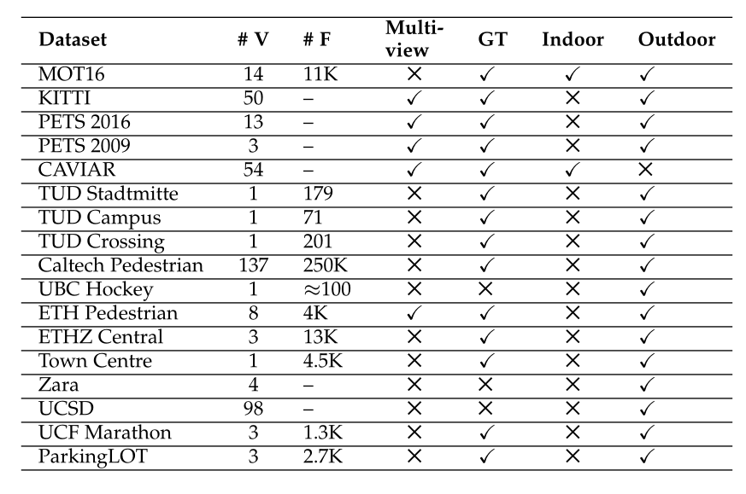

Indoor 室内 outdoor 室外

TABLE 8: Statistics of publicly available datasets. # V and # F mean how many videos and frames are included in the dataset. “Multi-view” and “GT” indicate whether multiview data and ground truth are provided. “Indoor” and “Outdoor” denote the types of scenarios in the dataset. For the last four items, the check and cross marks mean YES and NO, respectively. The page of a dataset can be accessed by clicking the dataset name.

表8：公开可用数据集的统计。 #V和#F表示数据集中包含的视频和帧数。“Multi-view”和“GT”表示是否提供了多视角数据和真实目标标注。“Indoor”和“Outdoor”表示数据集的场景类型。对于最后四项，检查和交叉标记分别表示YES和NO。单击数据集名称可以访问数据集的页面。
These datasets have played an important role in the progress of MOT. However, there are some issues with them. First, the scale of datasets for MOT is relatively smaller than that of SOT, e.g., the sequences used in [29]. Second, current datasets focus on pedestrians. This can be attributed to the fact that pedestrian detection has achieved great success in recent years. However, exciting progress of multi-class detection has been achieved in more recent years. We believe multi-class-multi-object tracking is feasible building upon the detection module of multi-class objects. Thus, it is time to move towards datasets of multi-class objects for MOT.

这些数据集在MOT的发展中发挥了重要作用。但是，它们存在一些问题。 首先，MOT的数据集规模相对小于SOT的规模，例如[29]中使用的序列。其次，目前的数据集集中在行人身上。这可归因于近年来行人检测取得了巨大成功。然而，近年来多级检测已经实现了的令人兴奋的进步。我们认为基于多类物体的检测模块，多类多目标跟踪是可行的。因此，是时候转向MOT的多类物体的数据集。

4.3 Public Algorithms 公开的算法

We examine the literature and list algorithms with which the associated source codes are publicly available to make further comparisons convenient in Table 9.

我们检查文献算法，使用这些算法可以公开获得相关的源代码，以便在表9中进行进一步的比较。

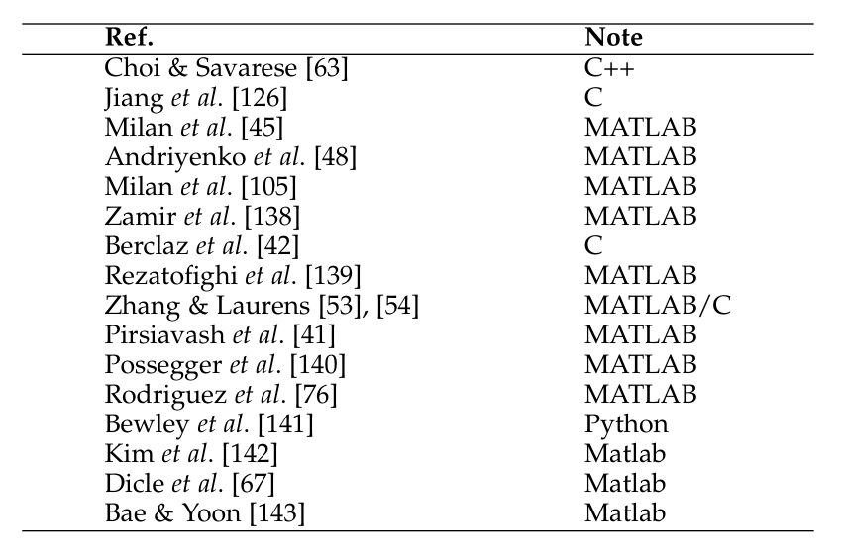

TABLE 9: A list of publicly available program codes. Please click the reference to access the page of the corresponding code.

表9：公开可用的程序列表。请单击引用以访问相应代码的页面。

Compared with SOT, there seem not many public programs. Admittedly, progress in SOT is larger than that of MOT recently. One reason can be that, many researchers have made their codes publicly available. We here encourage researchers to public codes for research convenience of others in the future.

与SOT相比，似乎没有太多的公共项目。不可否认，最近SOT的进展大于MOT的进展。一个原因可能是，许多研究人员已将其代码公之于众。我们在此鼓励研究人员将代码公布，以便将来其他人进行研究。

4.4 Benchmark Results 基准结果

We list public results on the datasets mentioned above to get a direct comparison among different approaches an provide convenience for future comparison. Due to space limitation, we only present results on the most commonly employed PETS2009-S2L1 sequence in Table 10. Results of other datasets are present in the supplementary material. Please note that this kind of direct comparison on the same dataset may not be fair due to the following points:

我们列出了上述数据集的公开结果，以便在不同方法之间进行直接比较，为将来的比较提供便利。 由于空间限制，我们仅在表10中显示最常用的PETS2009-S2L1序列的结果。其他数据集的结果存在于补充材料中。 请注意，由于以下几点，对同一数据集的这种直接比较可能不公平：

• Different methodologies. For example, some publications belong to offline methods while others belong to online ones. Due to the difference described in Section 2.2.2, it is unfair to directly compare them because the former have access to much more information.

•不同的方法。例如，一些论文使用离线方法，而其他一些论文使用在线方法。由于第2.2.2节中描述的不同，直接比较它们是不公平的，因为前者可以获得更多信息。

• Different detection hypotheses. Different approaches adopt various detectors to obtain detection hypotheses. One approach based on different detection hypotheses would output different results, let alone different approaches.

•不同的检测假设（也就是检测器检测的目标）。不同的方法采用各种检测器来获得检测假设。基于不同检测假设的同一种方法都会输出不同的结果，更不用说不同的方法。（不同方法使用不同检测器（不同方法）。同一种方法使用同一种检测器检测不同的目标（同方法不同检测假设））

TABLE 10: Quantitative results on the PETS2009-S2L1 dataset, extracted from the respective publications. Methods, ordered by public year, are labeled with Online and Offline tags. Concerning each metric, the best results are shown in bold. The table shows that a progress has been achieved while there seems not much research attention in this topic recently.

表10：从各自的论文中提取的对PETS2009-S2L1数据集的定量评估结果。方法按公共年度排序，标有在线和离线标签。关于每个指标，最佳结果以粗体显示。该表显示，虽然最近该主题似乎没有太多研究关注，但也已取得了进展。

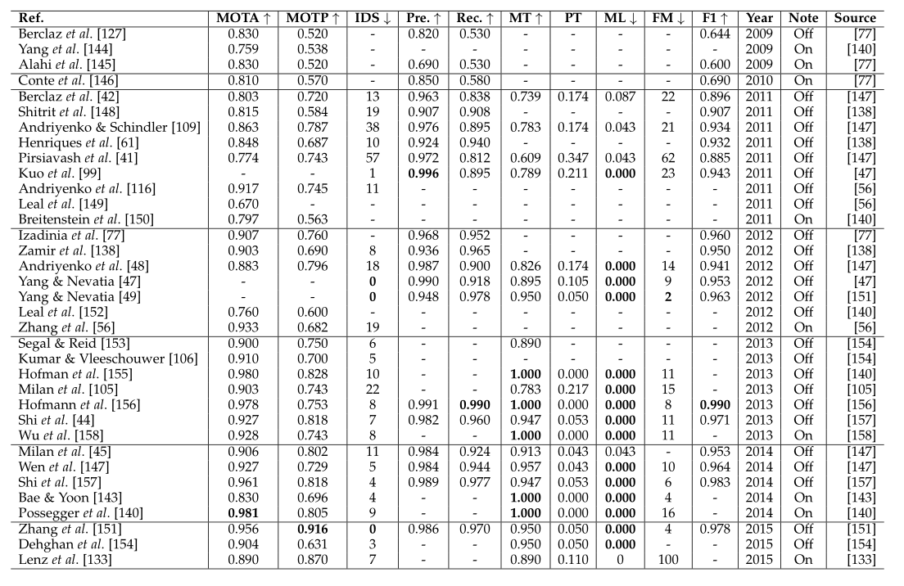
• Some approaches aggregate（集合，聚集） observations from multiple views while others utilize information from a single view. This makes a direct comparison between them difficult.

•有些方法汇总来自多个视图的观察结果，而有些方法则利用来自单个视图。这使得它们之间的直接比较变得困难。

• Prior information, such as scene structure and the number of pedestrians, are exploited（利用） by some approaches, making a direct quantitative（定量的） comparison to other methods which do not use that information questionable.

•某些方法利用了诸如场景结构和行人数量之类的先验信息，与其他不使用该信息的方法进行了直接的定量比较。（这种比较是不公平的）--个人见解

Strictly speaking, in order to make a direct and fair comparison, one needs to fix all the other components while varying the one under consideration. For instance, adopting different data association models while keeping all other parts the same could directly compare performance of different data association methods. This is the main goal of recent MOT benchmarks like KITTI [159] and MOTChallenge [30], [160], which specifically focus on a centralized evaluation of multiple object tracking. For intensive experimental comparison among different MOT solutions, please refer the respective benchmarks. In spite of the issues mentioned above, it is still worthy to list all the public results on the same dataset or sequence due to the following reasons.

严格地说，为了进行直接和公平的比较，需要在其他条件不变的情况下，改变要研究的条件（即控制变量法）。 例如，采用不同的数据关联模型同时保持所有其他部分相同，可以直接比较不同数据关联方法的性能。这是MOT基准测试的主要目标，如KITTI [159]和MOTChallenge [30]，[160]，它们专注于对多目标跟踪的集中评估。 有关不同MOT解决方案之间的密集实验比较，请参阅相应的基准。 尽管存在上述问题，但由于以下原因，仍然值得列出相同数据集或序列上的所有公开结果。

• By compiling all published results into a single table, it at least provides an intuitive comparison among different methods on the same dataset and a convenience for future works.

•通过将所有已发布的结果总结到单个表中，提供了对同一数据集的不同方法之间的直观比较，并为将来的工作提供了便利。

• Although this particular comparison among individual methods may not be fair, an approximate comparison between different types of methods such as that between offline and online methods could tell us how these types of methods perform on public datasets.
•虽然各个方法之间的特定比较可能不公平，但是在离线和在线中不同类型方法之间的近似比较可以告诉我们这些类型的方法如何在公共数据集上执行。

• Additionally, we could observe how the research of MOT progresses over time by comparing performance of methods across years.

•此外，我们可以通过比较多年来方法的表现来观察MOT的研究如何进展。
We report the results in terms of the MOTA, MOTP, IDS, Precision, Recall, MT, PT, ML, FM, and F1 metrics. At the same time, we tag the results with online and offline
lables. Please note that, 1) there missing entries, because we did not find the corresponding value neither from the original publication nor from other publications which cite it, and 2) in some cases, there could be different results for a unique publication (for example, results from the original publication versus results from another publication which compares with it). This discrepancy may arise because different configurations are adopted (e.g. different detection hypotheses). In this case, we quote the most popularly cited one.

我们根据MOTA，MOTP，IDS，Precision，Recall，MT，PT，ML，FM和F1指标报告结果。同时使用在线和离线标签来标记结果。请注意，1）缺少信息，因为我们没有从原始论文或引用它的其他论文中找到相应的值，2）在某些情况下，对于独特的论文可能会有不同的结果（例如 ，原始论文的结果与另一篇论文的结果相比较。由于采用了不同的设置（例如，不同的检测假设），可能出现这种差异。在这种情况下，我们引用最常被引用的一个。

We conduct an analysis of benchmark results on the PETS2009-S2L1 dataset to investigate the comparison between offline methods and online methods. Choosing results from publications that appeared in 2012 and later, we average values of each metric across each type of methods, and report the mean value in Table 11. As expected, offline methods generally outperform online ones w.r.t. most metrics. This is due to the fact that offline methods employ globally temporal information for the estimation.

我们对PETS2009-S2L1数据集的基准测试结果进行了分析，以研究离线方法和在线方法之间的比较。从2012年及以后出版的出版物中选择结果，我们对每种方法中每个指标的值进行平均，并在表11中报告平均值。正如预期的那样，离线方法通常优于在线方法（在大多数指标中）。这是因为离线方法使用全局时间信息进行估计。

Additionally, we analyze the evaluation results on the PETS2009-S2L1 dataset over time. Specifically, we plot the metric values of methods in each year ranging from 2009 to 2015 in Figure 7 and Figure 8. It is no surprise that the performance improves over the years. We suspect that contributors such as better models and progress in object detection [161], [162], [163], [164], [165] all contribute to the achieved progress. It should also be noted that a research community focuses on a specific dataset over time and certain methods may be a result of “over-fitting” to that dataset as opposed to general progress towards solving the problem.

此外，我们分析了PETS2009-S2L1数据集随时间的评估结果。具体而言，我们在图7和图8中绘制了2009年至2015年各种方法的指标值。多年来，性能得到改善也就不足为奇了。 我们认为，想更好的模型和更好的检测方法[161], [162], [163], [164], [165]，对检测的进步作出了贡献。还应该注意的是，研究团体随着时间的推移关注特定数据集，并且某些方法可能是对该数据集“过度拟合”的结果，而不是解决该问题的进展。

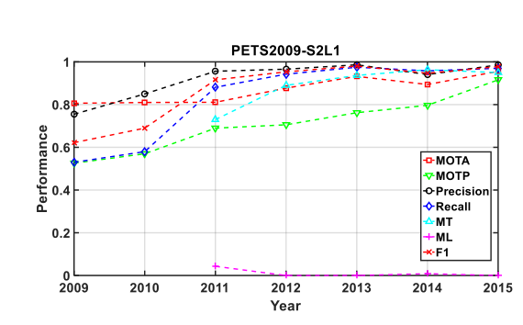
Fig. 7: Statistics of results in different years on the PETS2009-S2L1 dataset in terms of MOTA, MOTP, Precision, Recall, MT, ML and F1 metrics

图7：MOTA，MOTP，精确度，召回率，MT，ML和F1指标，PETS2009-S2L1数据集在不同年份的结果统计（表11中各种方法指标的平均）

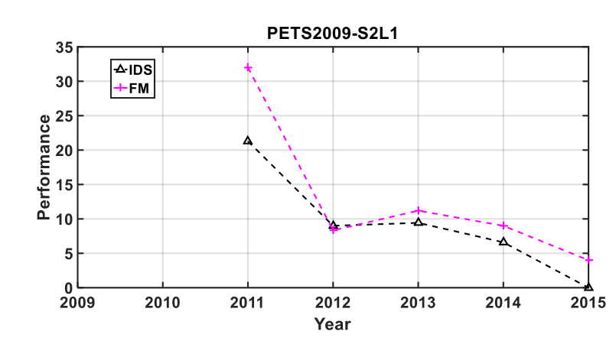
Fig. 8: Statistics of results in different years on the PETS2009-S2L1 dataset in terms of IDS and FM metrics
图8：IDS和FM指标，PETS2009-S2L1数据集在不同年份的结果统计

5 SUMMARY 总结

This paper has described methods and problems related to the task of Multiple Object Tracking (MOT) in videos. As the first comprehensive literature review in the past decade, it has presented a unified problem formulation and several ways of categorization of existing methods, described the key components within state-of-the-art MOT approaches, and discussed the evaluations of MOT algorithms including evaluation metrics, public datasets, open source implementations, and benchmark results. Although a great progress in MOT has been made in the past decades, there still remain several issues in the current MOT research and many open problems to be studied.

本文描述了与视频中多目标跟踪（MOT）任务相关的方法和问题。作为过去十年的第一次综合性文献综述，它提出了统一的问题表述和对现有方法的几种分类，描述了最新的MOT方法中的关键部分，并讨论了MOT算法的评估，包括评估指标，公共数据集，开源代码和基准测试结果。尽管在过去的几十年里，MOT已经取得了很大的进步，但目前的MOT研究仍然存在一些问题，还有许多待开发的问题需要研究。

5.1 Existing Issues 现存问题

We have discussed the existing issues of datasets (Section 4.2) and public algorithms (Section 4.3). Except these issues, there are still some remarkable ones as follows: One major issue in the MOT research is that, performance of an MOT method depends heavily on the object detectors. For example, the widely used tracking-by-detection paradigm is built upon an object detector, which provides detection hypotheses to drive the tracking procedure. Given different sets of detection hypotheses while fixing other components, an identical（相同的，相似的） approach would produce tracking results with significant performance differences. In the community, sometimes no description about the detection module is given in the approach. This makes the comparisons with other approaches infeasible. Established benchmarks like KITTI and MOTChallenge attempt to alleviate this problem and are also moving towards a more principled and unified evaluation of detection and tracking (cf. MOT17).

我们已经讨论了数据集（第4.2节）和已公开的算法（第4.3节）的现有问题。 除了这些问题，还有一些值得注意的问题如下：MOT研究的一个主要问题是，MOT方法的性能在很大程度上取决于物体检测器。例如，广泛使用的根据检测的跟踪方法(tracking-by-detection paradigm)建立在物体检测器上，物体检测器提供检测假设以驱动跟踪程序。在其他条件不变的情况下给定不同的检测假设集，相同的方法将产生具有显著差异的跟踪结果。在社区中，有时在该方法中没有给出关于检测模块的描述。这使得与其他方法无法进行比较。像KITTI和MOTChallenge这样正试图建立标准以缓解这个问题，并且正朝着更加原则和统一的检测和跟踪评估方向发展（参见MOT17）。

Another nuisance is that, when developing an MOT solution, there are many parameters if this algorithm is too complicated. This leads to a difficulty of tuning the method. Meanwhile, it is also difficult for others to implement the approach and reproduce the result.

另一个令人讨厌的问题是，在开发MOT解决方案时，如果此算法过于复杂，则有许多参数。这导致调整方法的困难。同时，其他人也难以实施该方法并重现结果。

Some approaches perform well in specific video sequences. While applied to other cases, however, they may not produce satisfying results. This may be caused from the fact that object detectors utilized by MOT approaches are trained in specific videos and do not generalize（推广） well in other video sequences.

一些方法在特定视频序列中表现良好。然而，对于其他情况，它们可能无法产生令人满意的结果。 这可能是由于MOT方法使用的物体检测器在特定视频中被训练而在其他视频序列中没有很好地推广。

All these issues restrict further development of the MOT research and its applications in practical systems. Recently, attempts to deal with some of these issues have been made, e.g., the MOT Benchmark [160] provides a large set of annotated testing video sequences, unified detection hypotheses, standard evaluation tools, etc. This is very likely to advance the further studies and developments of MOT techniques.

所有这些问题限制了MOT研究的进一步发展及其在实际系统中的应用。最近，人们已经尝试处理其中一些问题，例如，MOT Benchmark [160]提供了大量带注释的测试视频序列，统一检测假设，标准评估工具等。这很可能会进一步推进 MOT技术的研究和发展。

5.2 Future Directions 未来方向

Even after decades of research on the MOT problem, there are still numerous research opportunities in studying this problem. Here we would like to point out some more prevalent problems and provide possible research directions.

即使经过数十年对MOT问题的研究，仍然有许多研究这个问题的研究机会。在这里，我们想指出一些更普遍的问题，并提供可能的研究方向。

MOT with video adaptation. As mentioned above, the majority of current MOT methods requires an offline trained object detector. There arises a problem that the detection result for a specific video is not optimal since the object detector is not trained for the given video. This often limits the performance of multiple object tracking. A customization（定制的） of the object detector is necessary to improve MOT performance. One solution proposed by Shu et al. [166] adapts a generic pedestrian detector to a specific video by progressively refining the generic pedestrian detector. This is one important direction to follow in order to improve the pre-processing stage for MOT methods.

适应视频的多目标跟踪（检测器是针对特定视频进行训练的）。如上所述，大多数当前的MOT方法需要离线训练的物体检测器。这样产生了一个问题：特定视频的检测结果不是最佳的，因为对象检测器没有针对给定视频进行训练。 这通常会限制多个对象跟踪的性能。 必须定制物体检测器以改善MOT性能。 Shu等人提出的一种解决方案[166]，通过逐步改进通用行人检测器来使通用行人检测器适应特定视频。 这是为了改进MOT方法的预处理阶段而应遵循的一个重要方向。

MOT under multiple cameras. It is obvious that MOT would benefit from multi-camera settings [167]. There are two kinds of configurations of multiple cameras. The first one is that multiple cameras record the same scene, i.e., multiple views. However, one key question in this setting is how to fuse the information from multiple cameras. The second one is that each camera records a different scene,
i.e., a non-overlapping multi-camera network. In that case, the data association across multiple cameras becomes a reidentification problem.

多台摄像机下的MOT。 多相机有助于更好地进行多目标跟踪[167]。多个摄像头有两种配置。 第一个是多个摄像机记录相同的场景，即多个视图。 但是，此设置中的一个关键问题是如何融合来自多个摄像头的信息。 第二个是每个摄像机记录不同的场景，即非重叠的多摄像机网络。在这种情况下，多个摄像机的数据关联成为重新识别问题。

Multiple 3D object tracking. Most of the current approaches focus on multiple object tracking in 2D, i.e., on the image place, even in the case of multiple cameras. 3D tracking [168], which could provide more accurate position, size estimation and effective occlusion handling for high-level computer vision tasks, is potentially more useful. However, 3D tracking requires camera calibration, or has to overcome other challenges for estimating camera poses and scene layout. Meanwhile, 3D model design is another issue exclusive to 2D MOT.

三维多目标跟踪。大多数当前的方法都集中在2D中的多个物体跟踪，即在图像位置，即使在多个相机的情况下也是如此。 3D跟踪[168]可以为高级计算机视觉任务提供更准确的位置，大小估计和有效的遮挡处理，这可能更有用。然而，3D跟踪需要相机校准，或者必须克服估计相机姿势和场景布局的其他挑战。 同时，3D模型设计也是相对于2D的多目标跟踪独有的另一个问题。

MOT with scene understanding. Previous studies [35], [169], [170] have been performed to analyze over-crowded scenarios such as underground train stations during peak hours and demonstration at public places. In this kind of scenarios, most objects are small and/or largely occluded, thus are very difficult to track. The analyzing results from scene understanding can provide contextual（上下文的） information and scene structure, which is very helpful to the tracking problem if it is better incorporated into an MOT algorithm.

MOT与场景理解。以前的研究[35]，[169]，[170]已经进行了分析过度拥挤的情景，如高峰时段的地下火车站和公共场所。在这种情况下，大多数物体很小或大部分被遮挡，因此很难跟踪。场景理解的分析结果可以提供上下文信息和场景结构，如果将其更好地结合到MOT算法中，这对跟踪问题非常有帮助。

MOT with deep learning. Deep learning based models have emerged as an extremely powerful framework to deal with different kinds of vision problems including image classification [171], object detection [163], [164], [165], and more relevantly single object tracking [161]. For the MOT problem, the strong observation model provided by the deep learning model for target detection can boost the tracking performance significantly [172], [173]. The formulation and modeling of the target association problem using deep neural networks need more research efforts, although the first attempt to employ sequential neural networks for online MOT has been made very recently.

MOT深入学习。 基于深度学习的模型已成为处理不同类型视觉问题的极其强大的框架，包括图像分类[171]，物体检测[163]，[164]，[165]，以及相关的单目标跟踪[161]。对于MOT问题，深度学习模型为目标检测提供的强大观测模型可以显着提高跟踪性能[172]，[173]。尽管最近已经在在线多目标跟踪(online MOT)采用顺序神经网络做了第一次尝试，但使用深度神经网络的目标关联问题的制定和建模需要更多的研究工作，

MOT with other computer vision tasks. Although multiple object tracking is in serve of other high-level computer vision tasks, there is a trend to solve multi-object tracking with some other computer vision tasks jointly as they are beneficial to each other. Possible combinations include object segmentation [174], human re-identification [175], human pose estimation [17], and action recognition [18].

MOT与其他计算机视觉任务。尽管多目标跟踪服务于其他高级计算机视觉任务，但是存在一种趋势，即联合处理多目标跟踪以及其他一些计算机视觉任务，因为它们彼此有益。 可能的组合包括对象分割[174]，人类重新识别[175]，人体姿势估计[17]和动作识别[18]。

Besides the above future directions, since the current MOT research is mainly focused on tracking multiple humans in a surveillance scenario, the extensions of the current MOT research to other types of targets (e.g., vehicles, animals, etc.) and scenarios (e.g., traffic scenes, aerial photographs, etc.) are also very good research directions, since the problem settings and difficulties for tracking different types of targets under different scenarios are sometimes quite different from those in tracking multiple humans in a surveillance scenario.

除了上述未来方向，由于目前的MOT研究主要集中在监控场景中跟踪多个人，当前MOT研究扩展到其他类型的目标（例如，车辆，动物等）和场景（例如， 交通场景，航空照片等也是非常好的研究方向，因为在不同情景下跟踪不同类型目标的设置和困难与在监视场景中跟踪多个人有很大不同。

